This document provides the teacher with several optional supplemental handouts that can be used in the lesson Addition and Subtraction of Rational Numbers, Part 2.
1. Did You Hit the Target? Rules and Scoring Sheet – allows students to keep the score if the teacher decides to conduct the Part 2 of the activity as a game. In this game students work in pairs and generate new addition and/or subtraction problem. One of the students solves the problem by hand and then checks his/her solution using interactive number line model provided in the TI-Nspire document. The second student records the number of attempts it took. Students then switch the roles. Make copy of the rules and scoring sheet for each student.
2 Addition and Subtraction of Mixed Numbers. Summary Chart. - allows students to summarize the results of the activity when answering question 5 of part 2. The blank chart and the chart with sample answers are provided.

DID YOU HIT THE TARGET?
Rules and Scoring Sheet

This is a two-player game. In each round of the game “the player” will try to “hit the target” by solving an addition or subtraction problem with as few attempts as possible. The “score keeper” will keep record of number of attempts it took and calculate the total score for the round. You will switch the roles each round. Follow teacher’s instructions on how much time or how many rounds you can play. At the end of the game find total scores for both of you.
Rules:
Player | Score Keeper
- Generate new problem per instructions in your student activity sheet.  - Solve the problem without calculator and record value of b.  - Use the Number Line interactive model in the TI-Nspire document to check your solution.  - Try again if you did not hit the target. | - Tally number of attempts for the given problem  - Record the total number of attempts  - Use the scoring system to determine the final score as following:  - 1 attempt – 2 points  - 2 attempts – 1 point  - 3 or more attempts – 0 points

Number of rounds played _______
Name ______________________________________ Total Score _______
Name ______________________________________ Total Score _______

DID YOU HIT THE TARGET?
Player Name _______________________________________________________
Record your problem:
VALUE OF | DID YOU HIT THE TARGET? | ATTEMPTS
 | Yes No
 | Yes No | SCORE
 | Yes No

Record your problem:
VALUE OF | DID YOU HIT THE TARGET? | ATTEMPTS
 | Yes No
 | Yes No | SCORE
 | Yes No

Record your problem:
VALUE OF | DID YOU HIT THE TARGET? | ATTEMPTS
 | Yes No
 | Yes No | SCORE
 | Yes No

Record your problem:
VALUE OF | DID YOU HIT THE TARGET? | ATTEMPTS
 | Yes No
 | Yes No | SCORE
 | Yes No

ADDITION AND SUBTRACTION OF MIXED NUMBERS – SUMMARY CHART
Instructions: for each case show addition or subtraction using vectors. Use a blue pencil for negative numbers and a red pencil for positive numbers. Mark the result of the operation on the number line. Then record an inequality that indicates the relationship between and 0.

 | Addition: | Subtraction:
 | 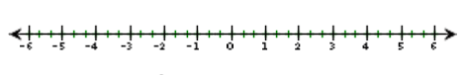
ADDITION AND SUBTRACTION OF MIXED NUMBERS – COMPLETED CHART

 | Addition: | Subtraction:
 | 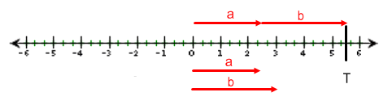 | ,  If If  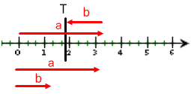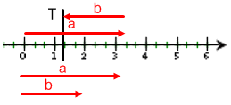  ,  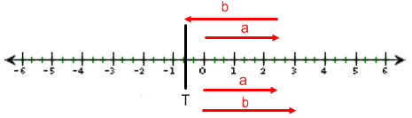
 | 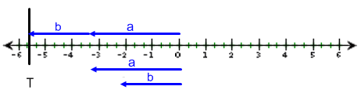 | ,  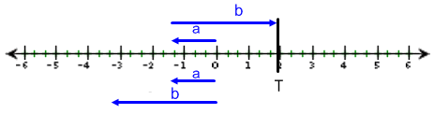  ,  If If  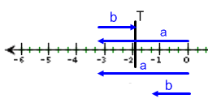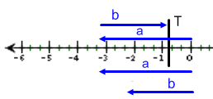
 | ,  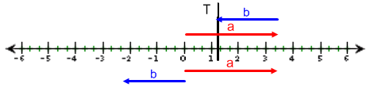  ,  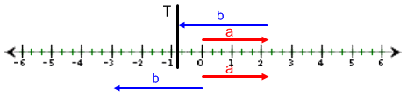 | 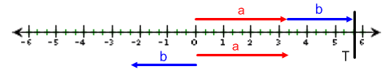
 | ,  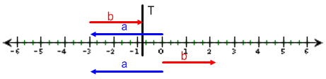  ,  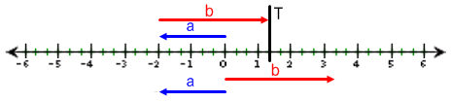 | 