Open the TI-Nspire document Radian_Measure.tns.  In this activity, you will define a radian and discover how to convert from radians to degrees and vice versa. | 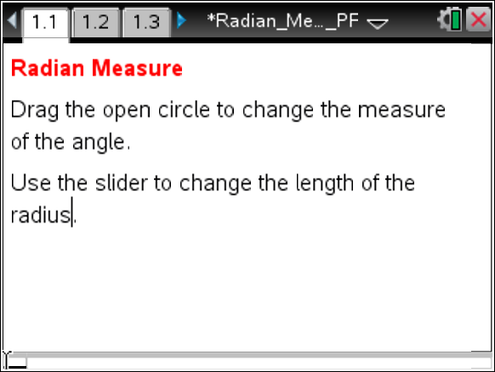

Move to page 1.2.

1. Drag the open circle until the arc length and the radius are equal. What do you observe about the radian measure of the central angle?

2. Drag the open circle farther along the arc.
a. What is the central angle measure when the length of the arc is twice the length of the radius?

b. What do you expect the arc length to be when the angle measure is 3 radians? Explain your reasoning.

3. Click the slider to change the length of the radius. Are the observations you made in Questions 1 and 2 still true? Explain why or why not.

4. Define a radian.

Move to page 1.3.

5. Drag the open circle counterclockwise as far as possible.
a. What is the approximate radian measure of the central angle?

b. What symbol do we use for this approximation?

c. What is the degree measure of the central angle?

d. Write an equation to represent the relationship between the radian and degree measures of the central angle.

6. Drag the open circle until the central angle is a right angle.
a. Write this approximation as an exact value.

b. Write an equation to represent the relationship between the radian and degree measures of the right angle.

7. Click the slider to change the radius. Do the relationships you discovered in Questions 5 and 6 remain the same? Why or why not?

8. How could you determine the exact radian measure of a 45-degree angle?

9. How could you determine the degree measure of an angle that measures radians?

10. Write a proportion that can be used for converting any radian measure to degree measure and vice versa.

11. Use the proportion from Question 10 to determine the radian measure of a 280-degree angle.

