Exploring Magnetism
Magnetism is the force of attraction or repulsion between a magnet and something else. Magnets attract materials made of iron, nickel, or cobalt. Can you think of five things to which a magnet may be attracted? Does it matter which end of the magnet is brought near the object.
Magnetic field of a magnet

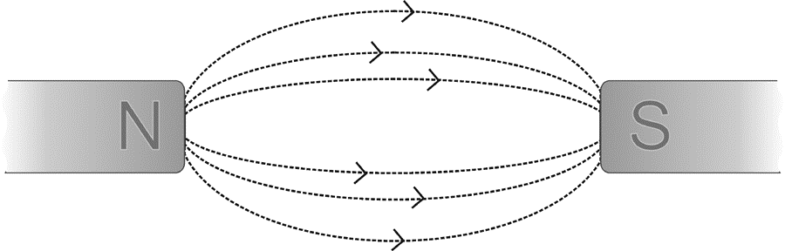
All magnets, no matter what their shapes, have two regions called the north and south poles. The north pole of the magnet is the one that points north when the magnet is suspended in the air. When two like poles (i.e. north and north or south and south) are brought near each other, they repel each other. When two unlike poles are brought together they are attracted. The forces of repulsion and attraction are present because of the magnetic field that completely surrounds the magnet. Magnetic field lines extend out from the north pole into the south pole.
Like poles repel
Unlike poles attract
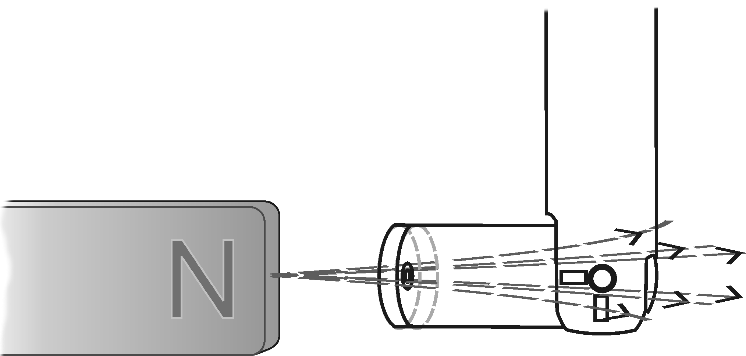
The field lines are more concentrated near the poles of the magnet so the magnetic field is said to be stronger near the poles. The strength of the magnetic field can be measured using a Magnetic Field Sensor. The greater the number of magnetic field lines that pass through the white dot on the sensor, the stronger the field. When the field lines enter the side of the sensor with the white dot, the magnetic field reading is negative. What do you think would happen if the Magnetic Field Sensor were turned around so that the lines passed from the back of the sensor? You will investigate this in Part I of this experiment. In Part II of this experiment you will investigate the relationship between the orientation of the Magnetic Field Sensor and the strength of the magnetic field.
Magnetic field lines through the sensor
OBJECTIVES
In this experiment, you will
- Investigate the response of a Magnetic Field Sensor in the presence of a magnet under various conditions.
- Investigate the relationship between the orientation of the sensor and the strength of the magnetic field.

MATERIALS
TI-Nspire handheld or | tape
computer and TI-Nspire software | pointer
data-collection interface | scissors
Vernier Magnetic Field Sensor | paper clips
unmarked bar magnet or cow magnet | small stickers (optional)
degree wheel

PRE-LAB QUESTIONS
1. What happens when you bring a magnet close to some paper clips? Does it matter which end of the magnet is brought near them?
2. What happens when you bring two magnets close to one another? What happens if you turn one of the magnets around?

PROCEDURE
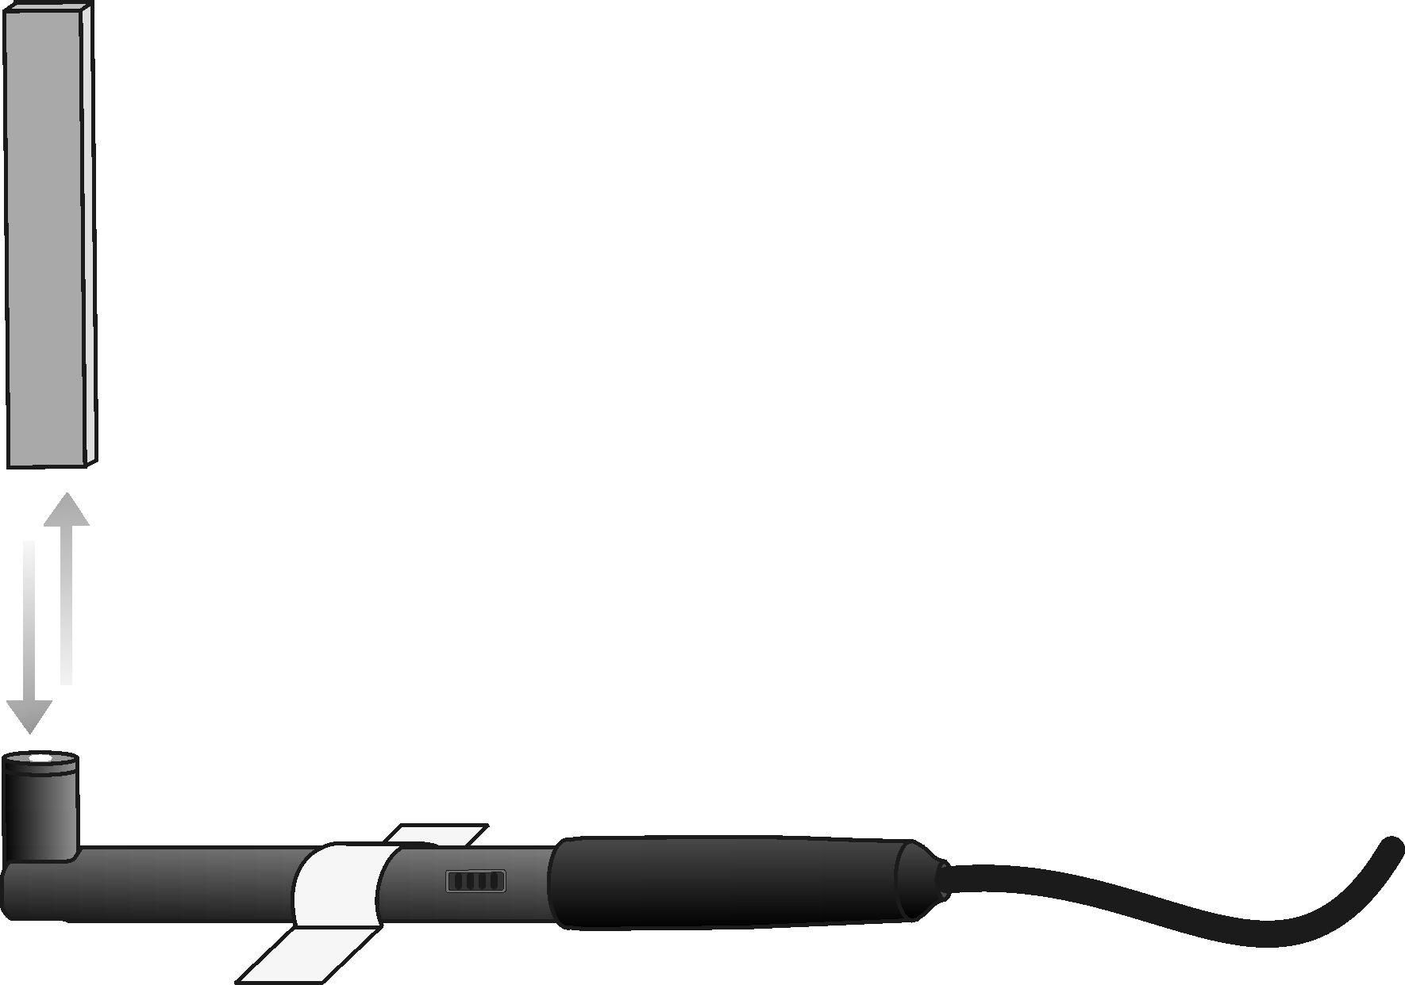
Part I Investigating Bar Magnets
Figure 1
1. Tape the Magnetic Field Sensor to the table with the white dot facing up (see Figure 1). When placing your sensor, avoid things such as electrical wires, computer monitors, or metal brackets as these can interfere with your sensor.
2. Set the switch on the Magnetic Field Sensor to 6.4 mT (low amplification). Connect the Magnetic Field Sensor to the data-collection interface. Connect the interface to the
TI-Nspire handheld or computer.
3. Choose New Experiment from the Experiment menu. Choose Collection Setup from the Experiment menu. Enter 2 as the rate (samples/second) and 10 as the experiment duration in seconds. The number of points collected should be 21. Select OK.
4. Zero the Magnetic Field Sensor. This reduces the effect of the surrounding environment on the magnetic field reading.
- Move all magnets far away from the Magnetic Field Sensor.
- When the readings on the screen stabilize, choose Set Up Sensors ► Zero from the Experiment menu. When the process is complete, the readings for the sensor should be close to zero.

5. Hold the magnet vertically about 20 cm above the Magnetic Field Sensor. One end of the magnet should be lined up with the white dot on the sensor as shown in Figure 1.
6. Start data collection (). Slowly move the magnet toward the Magnetic Field Sensor and then away. You have 10 seconds to complete this motion. Keep track of which end of the magnet you have tested.
7. Sketch and label the resulting graph on the blank graph titled Trial 1 in the Data section.
8. Turn the magnet around so that the other end is facing the white dot on the Magnetic Field Sensor.
9. Click on the Store Data Button () to store the first run data. Repeat Steps 6 and 7 but sketch your results in the graph titled Trial 2 in the Data section.
10. Place a sticker (or small piece of tape) on the end of the magnet that produced a positive reading with the Magnetic Field Sensor.
11. Remove the tape from the Magnetic Field Sensor and turn it over so that the white dot faces down. Tape the sensor to the table.
12. Zero the Magnetic Field Sensor in the new position.
- Click the Meter View tab ().
- Move all magnets far away from the Magnetic Field Sensor.
- When the readings on the screen stabilize, choose Set Up Sensors ► Zero from the Experiment menu. When the process is complete, the readings for the sensor should be close to zero.

13. Hold the magnet with the sticker pointing down toward the Magnetic Field Sensor.
14. Start data collection (). Slowly move the magnet toward the Magnetic Field Sensor and then away. You have 10 seconds to complete this motion.
15. Sketch and label the resulting graph on the graph titled Trial 3 in the Data section.
Part II Magnetic Field Sensor Orientation
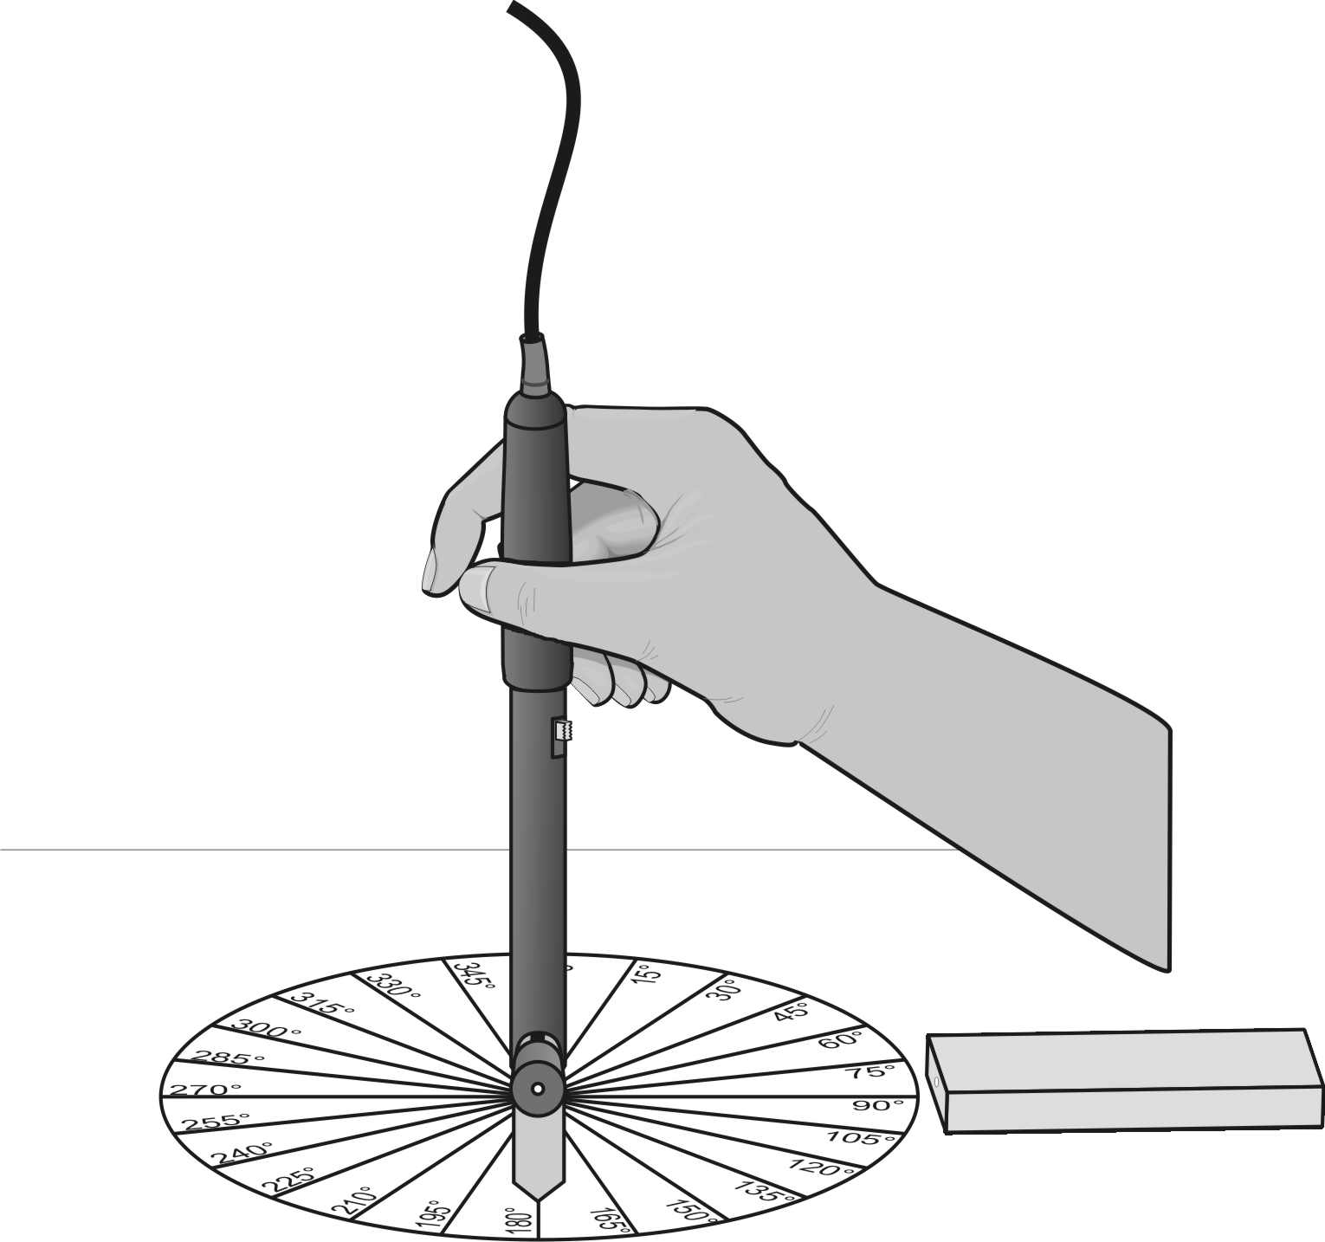
16. Remove the tape holding the Magnetic Field Sensor to the table.
Figure 2

17. Cut out the degree wheel and pointer supplied by your teacher.
18. Tape the degree wheel to the table with 0° pointing away from you and 90° pointing to your right.
19. Place the bar magnet on 90° with the end of the magnet with the sticker from Part I pointing toward the center of the circle. Tape the magnet to the table.
20. Tape the pointer on top of the white dot of the Magnetic Field Sensor and bend it so that it is perpendicular to the sensor as shown in Figure 2.
21. Set up Events with Entry data collection.
- Insert a new problem into your TI-Nspire Document and insert a DataQuest Application.
- Choose Collection Mode ► Events with Entry from the Experiment menu.
- Enter Position as the Name and deg as the Units. Select OK.

22. Place the tip of the Magnetic Field Sensor on the center of the degree wheel with the pointer pointing toward 0°. Hold the sensor vertically.
23. Start data collection ().
24. Measure the magnetic field at the zero degree position.
- When the magnetic field readings stabilize, click the Keep button ().
- Enter 0 (the position in degrees). Select OK to save this data pair.

25. Rotate the Magnetic Field Sensor so that the pointer points toward 15º and repeat Step 24 entering the current pointer position. Make sure the Magnetic Field Sensor remains vertical.
26. Continue taking a data point every 15º until 360º is reached. When data collection is complete, stop data collection ().
27. To examine the data pairs on the displayed graph, use the touchpad or arrow keys to move the cursor near a desired point. Press  to select point to examine. Use the cursor and press to examine other points on the graph. Locate the point with the greatest magnetic field intensity. Record the position of the pointer in the Data section.
28. Sketch or print a copy of the graph as directed by your teacher.

DATA
Trial 1 Trial 2

Trial 3
DATA (cont.)
Part II
Greatest magnetic field intensity position ________º

QUESTIONS
1. What happens when you bring two like poles together? What happens when you bring two unlike poles together?
2. How is it possible that the same end of the magnet can produce both a positive and a negative magnetic field reading?
3. Based on your data from Part II, where (at what angle) was the white dot on the Magnetic Field Sensor pointing when it produced the greatest magnetic field intensity?
4. It is often said that the Earth behaves magnetically like a giant magnet. How could you use a Magnetic Field Sensor to determine which direction is North?

EXTENSION
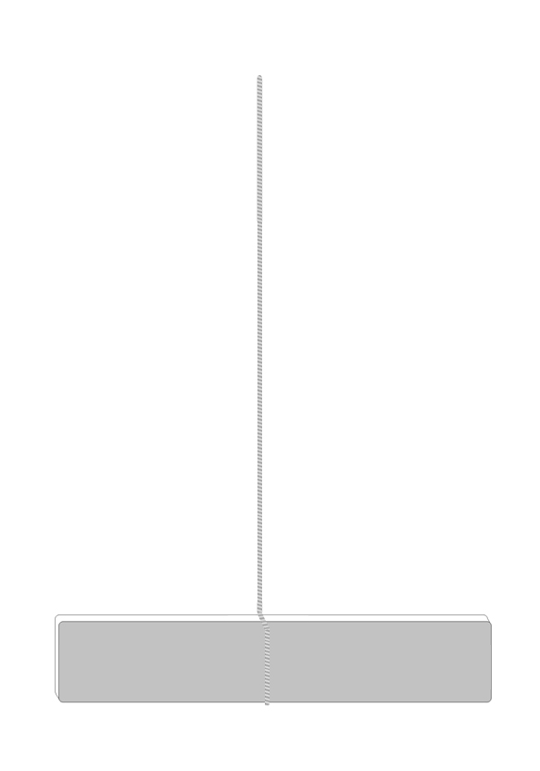
Measurements of the magnetic field around the Earth show that the Earth behaves magnetically like a giant magnet. It has both a north and south magnetic pole. The magnetic pole in the Northern Hemisphere is the point to which the north end of a compass or suspended bar magnet points.
Hanging bar magnet
To show that this is true
- Hang an unmarked bar or cow magnet from a piece of string and let it come to rest.
- Put a sticker or small piece of tape on the end that points toward north.
- Determine whether the end that points north produces a positive or a negative magnetic field reading by repeating Steps 1–8.

1. Does the end that points North give a positive or negative magnetic field reading?

2. Make a sketch of the magnetic field lines around the bar magnet.

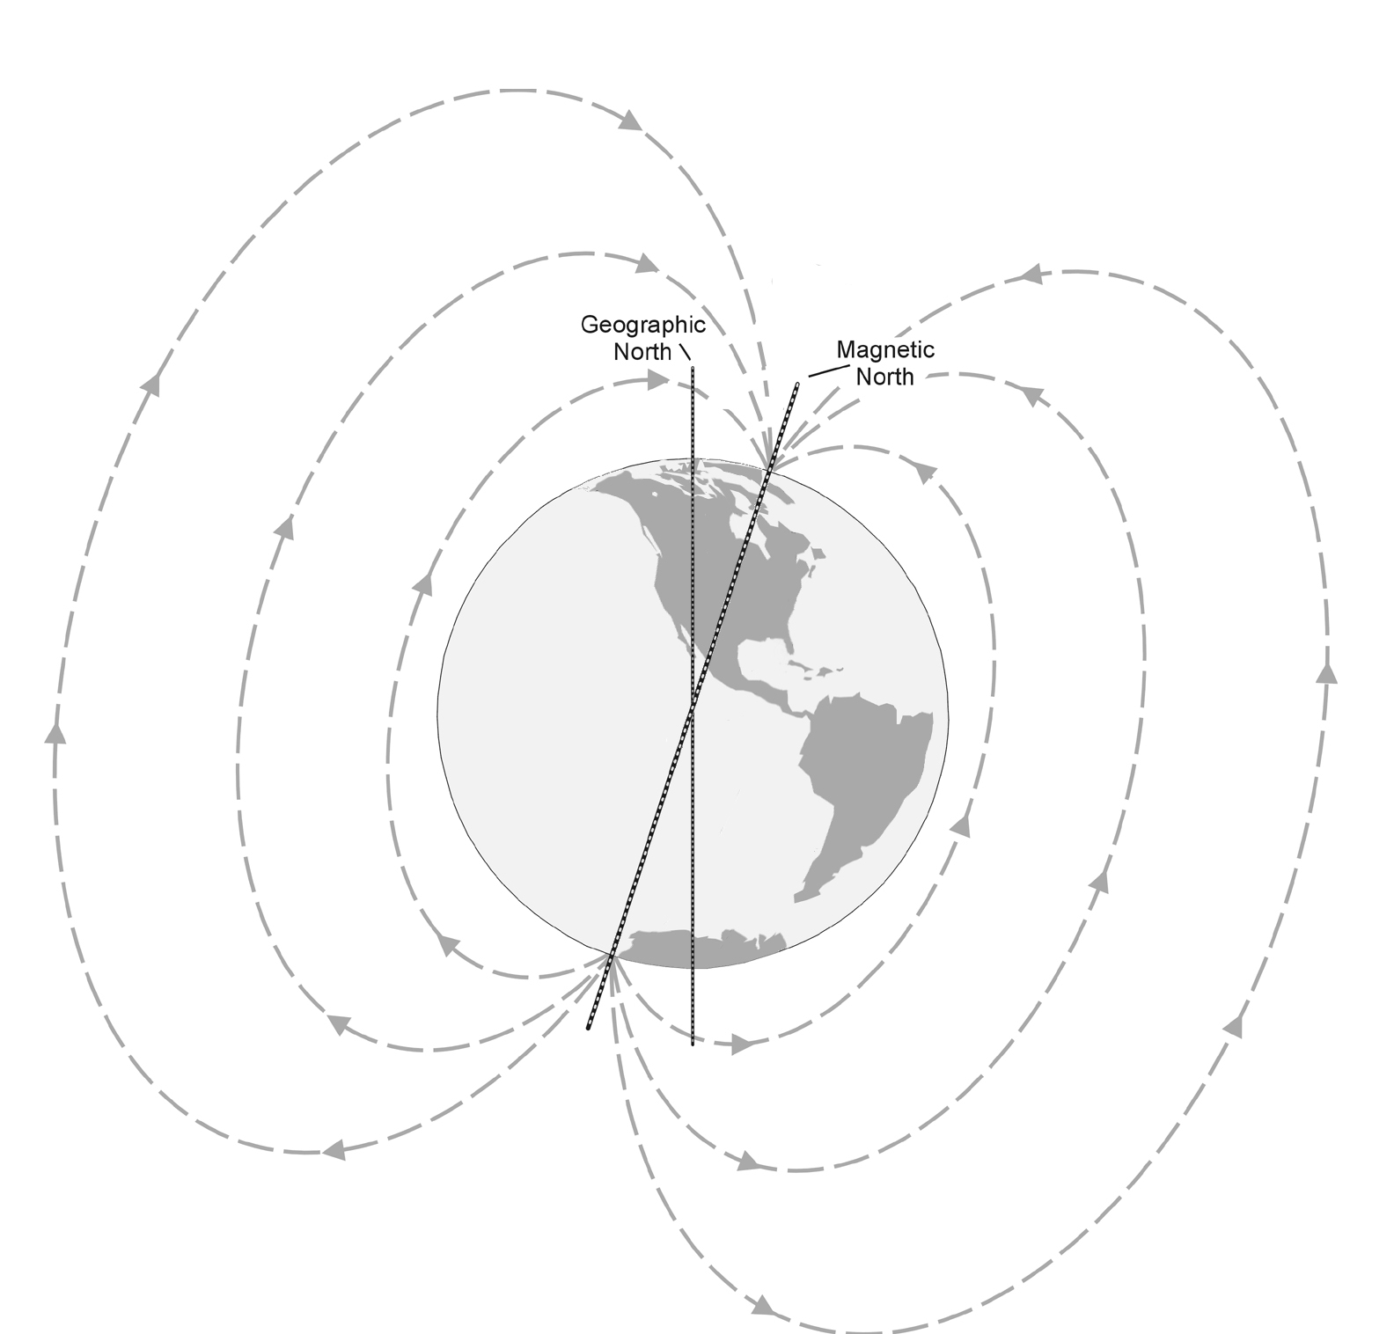
3. If unlike poles attract and the north end of the magnet points toward the magnetic pole in the Northern Hemisphere, what type of pole, north or south, must the magnetic pole in the Northern Hemisphere be?
Earth’s magnetic field

