Open the TI-Nspire document Logarithmic_Transformations.tns.  The graph of any function can be moved on the x-axis or y-axis following a few rules. In this activity, you will discover these rules for logarithmic functions. | 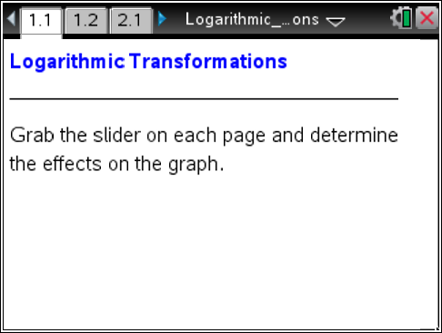

Move to page 1.2.

1. For this activity, the function used is. This activity’s investigations also work for any b > 0 and b ≠ 1.
a. What effect does dragging the k-value have on the parent function?
Change the k-value by grabbing and dragging the slider. What happens algebraically to the point (1, 0) in terms of k as the graph gets translated up or down?

b. Name the transformation (including its distance and direction) when the function changes to.

Move to page 2.1.

2. Change the h-value by grabbing and dragging the slider.
a. What happens to the equation and graph when h < 0?

b. Name the transformation (including its distance and direction) when the function changes to.

c. Chris says that the point (1, 0) on the parent function translates to (–3, 0) when she drags the h-value to –4 because the log of 1, base 3 is zero. Is her explanation mathematically correct? Explain. Change the h-value and confirm your explanation by grabbing and dragging the slider.

Move to page 3.1.

3. Change the a-value by clicking the arrows.
a. As the a-value changes the graph, explain why the point (1, 0) remains on the transformed graph.

b. When the graph is changed to, what transformation has occurred? Describe the transformation in terms of what is happening with the points.

Move to page 4.1.

4. Change the b-value by clicking the arrows.
a. When b < 0, what happens to the graph?

b. What other effects does the b-value have on the graph?

c. Suppose the function changes from to. Describe the transformation that occurs.

Move to page 5.1.

5. Apply what you have learned and change the values of variables h, k, a, and b by clicking their arrows so that the dashed graph is transformed to the solid graph in the displayed domain. It will say correct when you have done it correctly. Write the correct function here.

6. Nate says that transforming to is a horizontal translation of 2 to the right. Is Nate correct? Why or why not?

7. What is the equation of the parent function y = log(x) translated 5 to the left and 2 up?

8. a. Write the function that transforms y = x² with a horizontal translation to the right of 5 and a vertical dilation by a factor of 7.

b. Write the function that transforms y = x with a vertical translation down 3 units.

