Open the TI-Nspire document The_Unit_Circle.tns.  In this activity, you will click on a slider to change the measure of the central angle and create a series of line segments that determine the graph of a sinusoidal function. | 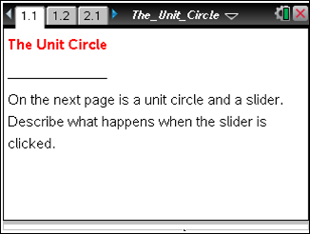

Move to page 1.2.

1. The circle pictured is called a unit circle. Why is that term used?

2. Use the slider to make three segments appear. What is the relationship between the right triangle in the unit circle and the vertical line segments?

3. Will the lengths of the line segments continue to increase? Why or why not?

4. Continue to use the slider until you obtain values of θ such that < θ < π. Are any of the line segments the same size? Why or why not?

5. Use right triangle trigonometry to explain the relationship between the angle θ and the highlighted leg of the right triangle in the unit circle. What trigonometric function can be represented by the length of the leg of the right triangle?

6. Use the slider until you obtain values of θ such that π < θ < . Explain the placement of the line segments.

7. Continue to use the slider until θ = 2π to graph a continuous function. What do the coordinates of the points on the continuous function represent?

8. Write an equation of the continuous function graphed.

9. If we continued to graph the function for values of θ such that 2π < θ < 4π, describe what you would expect to see. Explain your reasoning.

Move to page 2.2.

10. Use the slider until three segments appear. What is the relationship between the right triangle in the unit circle and the vertical line segments?

11. Use right triangle trigonometry to explain the relationship between the angle θ and the highlighted leg of the right triangle in the unit circle. What trigonometric function can be represented by the length of the leg of the right triangle?

12. Use the slider until you obtain values of θ such that < θ < π. Explain the placement of the line segments.

13. Continue to use the slider until θ = 2π to graph a continuous function. What do the coordinates of the points on the continuous function represent?

14. Write an equation of the continuous function graphed.

15. How would you explain to a friend how to graph this function accurately on graph paper without using technology?

16. In terms of θ, represent the x- and y-coordinates of the point moving around the unit circle. Explain your reasoning.

