Activity Overview:  This activity provides the steps to create a TI-Nspire document that will be used to investigate side length and area in a rectangle with a fixed perimeter. An algebraic approach is used so that findings can be generalized to other rectangles.  Materials  • Technology needed (TI-Nspire™ handheld, computer software) | 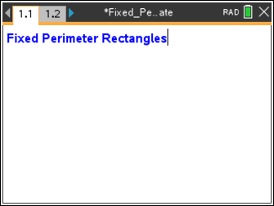
Step 1: Preparing the document  - Open a new document by pressing c > New Document > Add Notes.  - Type Fixed Perimeter Rectangles.  Note: To format the text, first select the text by holding down the shift key (g) and pressing the right or left arrow key on the Touchpad. Then, press Menu > Format > Format text, and select B for bold. Press d to exit Format text. To select a color for the text, press Menu > Format > Text color. Click the desired color, and then press x to deselect the text.  - Press ~ > File > Save. Type Fixed_Perimeter_Rectangles. Tab to ¾, and press ·.  Note: To obtain the underscore, press / _.  4. To add a new page, press / ~, and select Add Graphs.  5. Press Menu > Settings. Select Float 3 for display digits. Tab to Graphing Angle. Select Radian. Tab to Geometry Angle. Select Degree. Press e to move from one field to the next, and press x to uncheck each of the boxes. Tab to OK and press x or ·. Hide the entry line by pressing /G.  6. Change the graphing window to the settings shown to the right by pressing Menu > Window / Zoom > Window Settings. Press e to advance to the next input box. When completed, tab to OK, and press x or ·. | 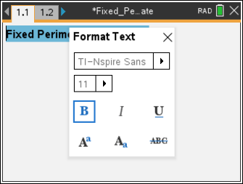  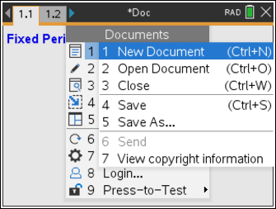  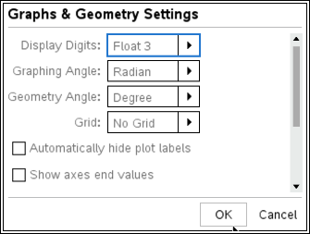  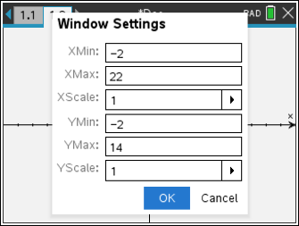
Step 2: Assigning a value to the perimeter  1. Move the cursor toward the right middle side of the screen.  2. Press Menu > Actions > Text. Press ·.  3. Type 20 in the text box, and then press ·.  4. Move the cursor toward the top middle of the screen. Press ·. Type Pp2 in the text box, and press ·.  5. Press d to exit the Text tool.  6. Press Menu > Actions > Calculate. Move the cursor near the expression. When the word expression appears, press x. | 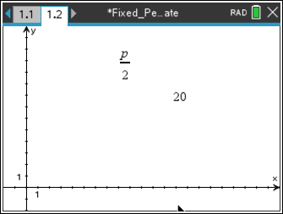  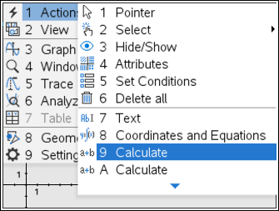
7. Move the cursor near the number 20. When the Select p? appears, press x to choose this value for p.  8. Move the value 10 near the expression, and press x.  9. Press d to exit the Calculate tool. | 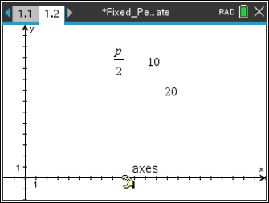
Step 3: Transferring a measurement  - To mark a point on each axis that corresponds to the value of, press Menu > Geometry > Construction > Measurement Transfer. This is the maximum value that either dimension can have,  - Move the cursor to the number 10, and press x to select the value. Move to the x-axis (“axis x” appears), and press x.  - Move the cursor to the number 10 again. Press x to select the value. Move to the y-axis (“axis y” appears), and press x.  - Press d to exit the Measurement Transfer tool. | 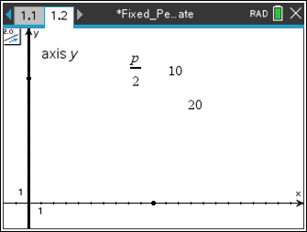
Step 4: Drawing a segment  1. Press Menu > Geometry > Points & Lines > Segment.  2. Move the cursor to the point on one of the axes, and press x. Move the cursor to the point on the other axis. Press x.  3. Press d to exit the Segment tool. | 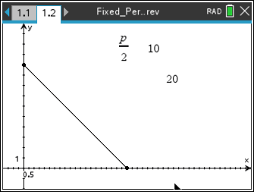
Step 5: Changing the scale  - Change the scale on the x-axis to 0.5 by double-clicking on the current scale of 1 and typing .5. Then press ·.  (This will allow the base measurement of the soon-to-be constructed rectangle to increase/decrease in increments of 0.5 units. In some cases, you may choose to change this value to 1 for whole-number values or to 0.1 to have the base and height measured to tenths.) | 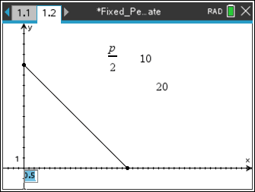
Step 6: Constructing perpendicular segments  - Make a line perpendicular to the x-axis through a point on the x-axis by pressing Menu > Geometry > Construction > Perpendicular.  - x on the x-axis to select it and then move along the x-axis until the words point on are displayed. Press x.  - Move towards the intersection of the line perpendicular to the x-axis and the segment. When the words intersection point appear, press x. Move to the y-axis, and press x.  - Press d to exit the Perpendicular tool.  - Find the point of intersection of the y-axis and the line perpendicular to the y-axis by pressing Menu > Geometry > Points & Lines > Intersection Point(s). Move the cursor to the perpendicular line and press x on the line; then move the cursor to the y-axis and press x. Then, find the point of intersection of the x-axis and y-axis by pressing x on the x-axis and pressing x again on the y-axis.  Press d to exit the Intersection Point tool. | 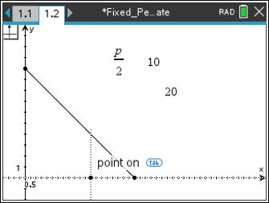  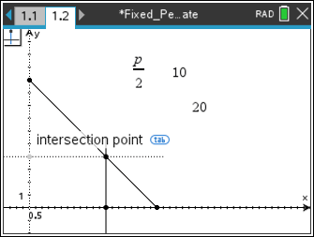
Step 7: Drawing a rectangle with the Polygon tool  1. A rectangle will be drawn using the point on the diagonal segment, the point on the x-axis determined by the perpendicular, the point on the y-axis determined by the perpendicular, and the origin.  Press Menu > Geometry > Shapes > Polygon.  2. Beginning with the point of intersection of the perpendicular line and the y-axis, move in a counterclockwise direction around the vertices, pressing x at each vertex point.  3. Return to the first vertex point marked, and press x to “close” the rectangle.  4. Press d to exit the Polygon tool. | 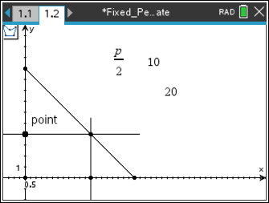
Step 8: Hiding objects  1. Press Menu > Actions > Hide/Show.  2. Move around the screen and press x to hide each object except the rectangle, the points which are the vertices of the rectangle, and the number 20, which indicates the perimeter of the rectangle.  Note: See the figure to the right to see what should be hidden.  - Press d to exit the Hide/Show tool. | 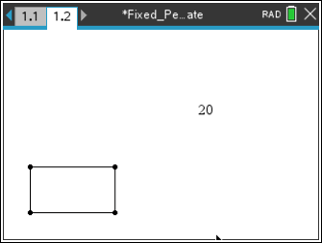
Step 9: Measuring base and height of the rectangle  1. Press Menu > Geometry > Measurement > Length.  2. Move to a vertex and press x. Move to an adjacent vertex and press x. Move the measurement to the desired location then press x.  3. Repeat for the other dimension.  4. Press d to exit the Length tool. | 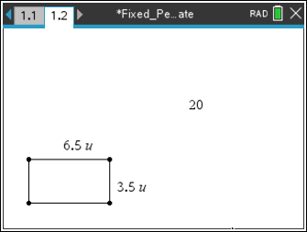
Step 10: Changing dimensions of the rectangle  1. The point that was marked on the x-axis will be used to change the dimensions of the rectangle. Move to that point, right-click (/b on the handheld), and choose Attributes.  2. Press ¢ until “Empty Large” appears. Press ·.  3. Hide the other three vertices by pressing Menu > Actions > Hide/Show and select the other three vertices, which are no longer needed. Then, press d.  4. Grab and drag the point left and right to change the dimensions of the rectangle. | 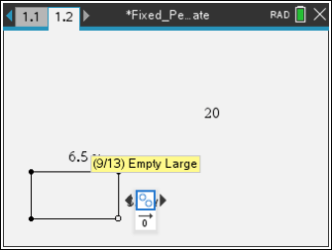
Step 11: Adding text and fixing measurements  Press Menu > Actions > Text to add text to the screen to help you organize the information.  - Move the cursor to the top of the screen. Press x and type the text below.  Fixed Perimeter Rectangles  Perimeter =  u (placed to the right of the value 20)  Area =  2. Press d to exit the Text tool.  3. Drag the point on the rectangle to these measurements for base and height: base = 6u and height = 4u. | 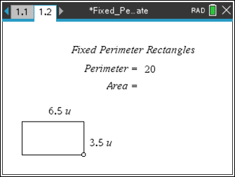
Step 12: Saving the document  1. Press / S. | 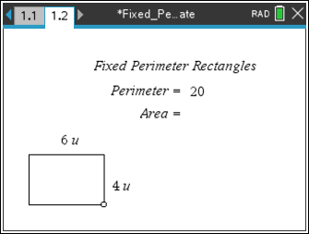
Alternate Method of Constructing a Rectangle with Fixed Perimeter  Step 1: Add a Geometry page  - Press / ~ > Add Geometry  - Press Menu > Shapes > Rectangle and draw a rectangle on the page. | 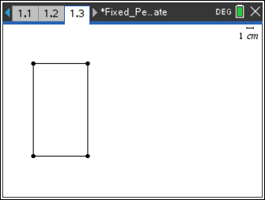
Step 2: Measure the lengths of the sides  - Press Menu > Measurement > Length. Move to a vertex, and press x. Move to an adjacent vertex, and press x. Move the measurement to the desired location, and then press x.  - Repeat for the other dimension.  - Press d to close the tool. | 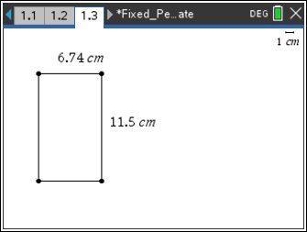
Step 3: Changing the measurements  - Move the cursor over the width measurement, and double click. This will open the text box for editing. Delete the numerical value and change it to 4 cm. Note: Make sure there is a space between the numerical value and the label.  - Move to the measurement for the length, and change it to 6 cm. | 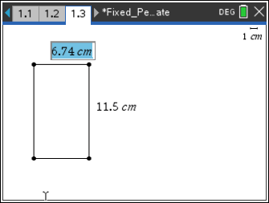  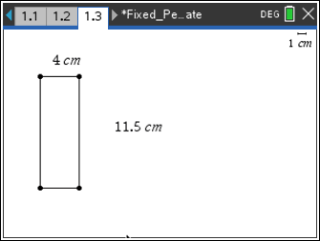  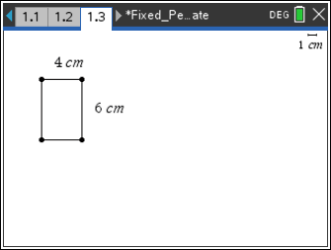
Step 4: Measuring the perimeter and locking its value.  - Press Menu > Measurement > Length, and determine the perimeter of the rectangle.  - Place the measurement on the page, and then close the tool by pressing d.  - Move the cursor to the perimeter measurement and right click. Select Attributes from the menu. Press ¤ to move to the second icon, the padlock, as shown in the accompanying diagram.  - Set the padlock to the locked position by clicking on the arrow to the right of the icon. Alternatively, press ¢ on the Touchpad.  - The message, (2/2) Object is locked, will be displayed. Press ·. | 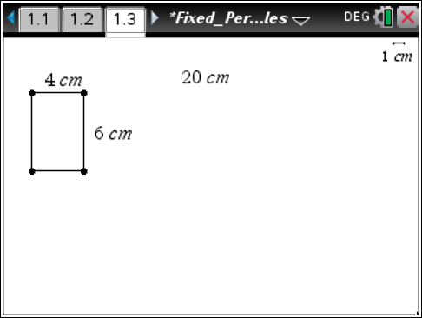  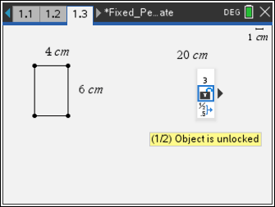  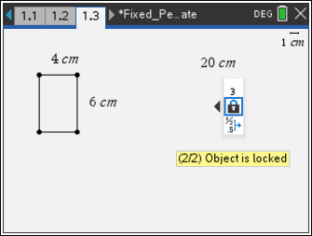
Step 5: Changing the point’s attribute  - Right click on the vertex in the top right corner of the rectangle, and change its attribute to “Empty Large.”  - Label the perimeter, and add a text box containing area=.  - Grab and drag the open point to verify that the rectangles drawn all have a constant perimeter of 20 cm.  Note: When the left and right base vertices are selected first when the rectangle is constructed, the upper vertices may be dragged to change the dimensions after the perimeter measurement is locked. | 