Open the TI-Nspire document Basic_Transformations.tns.  In this activity, you will manipulate sliders to change the values of parameters in trigonometric functions and to determine the effect that each change has on the shape of the graph. You will then use this knowledge to write equations for sine and cosine functions. | 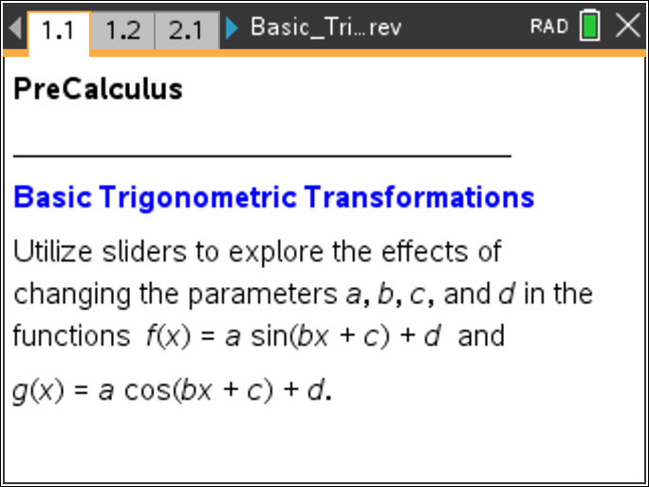

Move to page 1.2. | Press / ¢ and / ¡ to navigate through the lesson.
1. Drag the sliders to change the values of a and b in the function f(x) = a sin(bx).
a. Describe how the values of a and b affect the shape of the graph.

b. What happens to the graph if a is negative?

c. Complete the following statement:
For a ≠ 0 and b > 0, the graph of f(x) = a sin(bx) has an amplitude of ___________ and a period
of ___________.

Move to page 2.2.

2. Drag the slider to change the value of d in the function f(x) = sin(x) + d.
a. Describe how the value of d affects the shape of the graph.

b. Complete the following statement:
The graph of f(x) = sin(x) + d has a vertical shift of ___________.

Move to page 3.2.

3. Drag the slider to change the value of c in the function f(x) = sin(x + c). Describe how the value of c affects the shape of the graph.

Move to page 4.2.

4. Drag the slider to change the values of a, b, c, and d in the function f(x) = a sin(bx + c) + d.
a. Which of the four parameters have an impact on the horizontal shift of the graph?

b. Complete the following statement:
For a ≠ 0 and b > 0, the graph of f(x) = a sin(bx + c) + d has a horizontal shift of ___________.

5. For functions of the form f(x) = a sin(bx + c) + d or g(x) = a cos(bx + c) + d, with a ≠ 0 and
b > 0,
a. the amplitude is _________.

b. the period is _________.

c. the horizontal shift is _________.

d. the vertical shift is _________.

Move to page 5.4.

6. The function shown on this page has the equation f1(x) = –1.5sin + 4. Write an equation for a cosine function that will have the same graph.

Move to page 5.5.

7. The function shown on this page has the equation f2(x) = 3sin(2x) – 5. Write an equation for a cosine function that will have the same graph.

8. a. Write an equation for a sine function with an amplitude of 4, a period of 12, a horizontal shift of 2, and a vertical shift of 3.

b. Write an equation for a cosine function with the same parameters as the sine function in part (a).

9. a. Write an equation for the sine function whose graph is shown in the figure below.
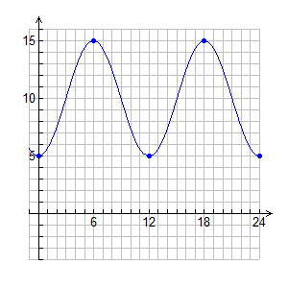
b. Utilize a cosine function to write an equation for the same graph.

