Introduction
When you move toward or away from an object, your distance from that object at any time can be plotted. From this distance-time graph, you can study how different types of motion affect the behavior of your plot. Changes in direction and other factors affect the shape of your plot.
Objectives  In this activity you will:  - Decide how to move in front of a CBR 2 to make a distance-time plot that increases as time increases.  - Decide how to move in front of a CBR 2 to make a distance-time plot that decreases as time increases.  - Decide how to move in front of a CBR 2 to make a distance-time plot that neither increases nor decreases.  You'll Need  - TI 84 Plus CE, with Vernier EasyData™ App  - CBR 2™ motion sensor unit with mini-USB connecting cable | 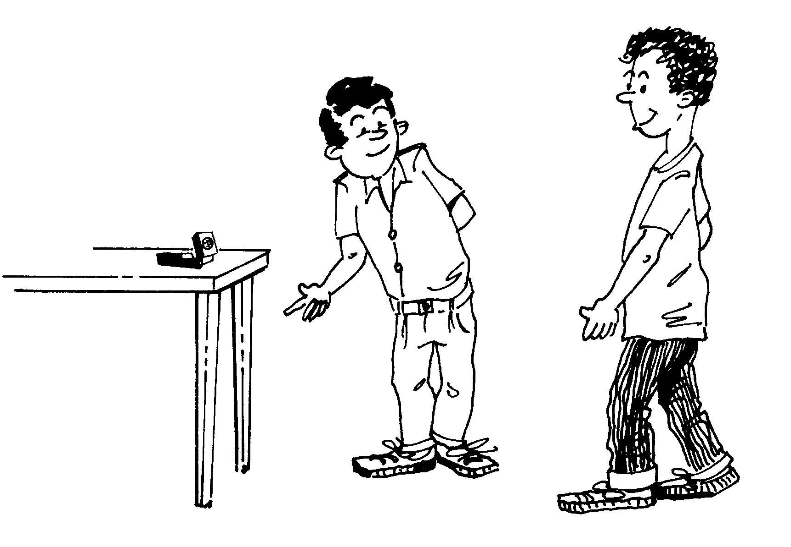
Using the CBR 2™ motion sensor and Vernier EasyData™ App  1. Connect the handheld with the CBR 2 using the USB cable. EasyData will immediately open, and the CBR 2 will begin collecting distance data every time it clicks. In the EasyData app, the tabs at the bottom indicate the menus that can be accessed by pressing the keys directly below. To go to File to select New, press o. To change the Setup, press q. To Start, press q. To see the Graph, press r. To Quit the app, press s. | 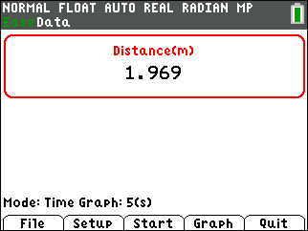
Trial 1  2. Write how you would walk in front of the CBR 2 in order to make the distance-time graph at the right. Record your description using accurate terms (where did you start, which direction did you walk, etc.). | 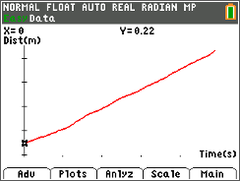
3. Try walking according to your description. If the graph is not what you want, go to the Main Menu by pressing s to start again. Select to overwrite the latest run. Before repeating, think about what you will do differently. Were you able to make the graph? Describe how you walked.

Trial 2  4. Write a description of how you would walk in front of the CBR 2 to make the distance-time graph at the right. Be precise using accurate terms (where did you start, which direction did you walk, etc.). | 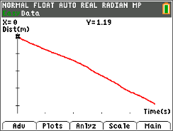
5. Repeat the walk if the graph you make is not what you want. Go back to the Main Menu by pressing s and then select Were you able to make the graph? How did you walk?

Trial 3  6. Look at this distance-time graph and describe how you would walk in front of the CBR 2 to make it. | 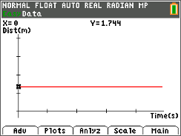
7. If your graph does not look right, try rescaling the graph before deciding if you were successful by selecting and the min and max numbers according to the values that will show your graph correctly. A sample is shown. | 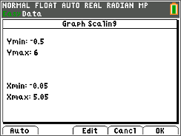
8. Repeat the walk if the graph you make is not what you want. Go back to the Main Menu by pressing s and then select Were you able to make the graph? How did you walk?
Looking at the Results
1. Why does the plot of Trial 1 go up as it moves from left to right? (Be sure to use the words “time” and “distance” in your explanation.)

2. Why does the plot of Trial 2 appear to be moving downward? (Be sure to use the words “time” and “distance” in your explanation.)

3. Why is the plot of Trial 3 a horizontal line? (Be sure to use the words “time” and “distance” in your explanation.)

4. Write a short paragraph summing up how the direction in which you move affects a plot of your distance from the CBR 2 with respect to time.

Going Further
1. If you combined the three previous trials into one trial by first walking away, then standing still, and finally walking toward the CBR 2, describe in words what the resulting plot would look like.

2. Make a sketch of the motion you described in question 1 and try it. Were you successful?

3. Try walking in front of the CBR 2 so that the distance-time graph will look like an uppercase ‘W.’ Write a summary of what you did.

4. Try walking in front of the CBR 2 so that the distance-time graph will look like an uppercase ‘O.’ Write a summary of what you did.

