Part 1 – Where Did All the y’s Go?
Determine how the y-coordinate of the given point in the screenshot changes with the given reflection.
1. Point is reflected over the y-axis.  Original: ______ New: ______  Point is reflected over the x-axis.  Original: ______ New: ______ |  | 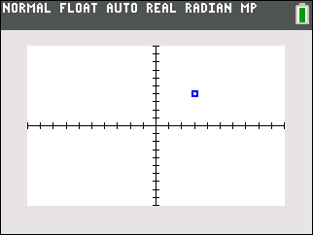
2. Point is reflected over the y-axis.  Original: ______ New: ______  Point is reflected over the x-axis.  Original: ______ New: ______ |  | 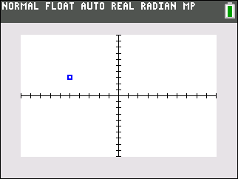
3. What happens to the y-coordinate of a point when reflected over the x-axis? y-axis?

Part 2 – Explore x-coordinate in Reflections
Determine how the x-coordinate of the given point in the screenshot changes with the given reflection.
4. Point is reflected over the y-axis.  Original: ______ New: ______  Point is reflected over the x-axis.  Original: ______ New: ______ |  | 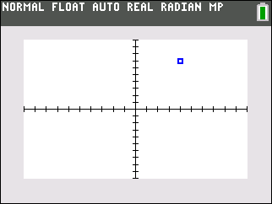
5. Point is reflected over the y-axis.  Original: ______ New: ______  Point is reflected over the x-axis.  Original: ______ New: ______ |  | 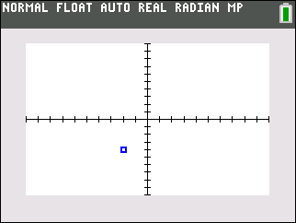
6. What happens to the x-coordinate of a point when reflected over the x-axis? y-axis?

Part 3 – Reflecting Figures over the x- and y-axes
Answer the following questions based on the image created by the given points. Draw the original figure on the given coordinate grid. Draw both reflected images and label the first R1 and the second R2.
7. L1 = {3, 5, 3, 5}  L2 = {2, 2, 7, 7}  R1: Reflect the image over the y-axis.  New L1:  New L2:  R2: Reflect the image over the x-axis.  New L1:  New L2:  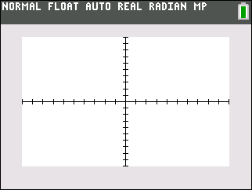 | 8. L1 = {3, 6, 1, 8, 3, 6}  L2 = {2, 2, 4, 4, 6, 6}  R1: Reflect the image over the y-axis.  New L1:  New L2:  R2: Reflect the image over the x-axis.  New L1:  New L2:
9. Graph the scatter plot of the following lists to create a letter of the alphabet.  L1 = {3, 3, 4, 6, 4, 6}  L2 = {8, 2, 8, 2, 4, 4}  Find a new L3 and L4 for the image reflected over the x-axis and the y-axis.  L3:  L4: | Draw the image of the original figure and reflection.
10. Explain how to create a new list of x- and y- values to display an image reflected over the x- and y-axes.

