Problem 1 – Number patterns can be revealed in a scatter plot.
To the right, you see the ordered pairs that will be plotted. Focus on the y-values.  - Can you figure out a mathematical pattern for these values? Write an explanation if you can. | 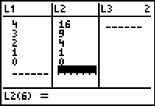
Set up Stat Plot 1 with the settings at the right using L1 and L2 shown.  Enter the next three y-values that follow the same pattern. Look at the scatter plot again.  - Do you see a visual pattern or shape? What is it? | 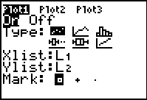
- Graph y = x² over the scatter plot. Do you agree that it matches the data? Why or why not?

- Now, use the matching function to predict a future term of the pattern. What is y(7)? From the Home screen, press       .

Problem 2 – A pattern that has a visual model with it
At the right, you will see stacks of bricks. Observe the pattern.  - Predict what the next pile will look like and sketch it below. | 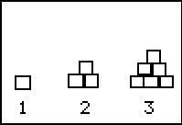
Enter the lists to the right. Enter the number you think will continue the pattern for Piles 4 and 5, representing how many bricks will be in the next larger “pile.” Then, examine a scatter plot of the data.  - What shape does the data form? | 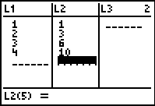

Problem 3 – A pancake in the air? An application of a parabola at breakfast time!
Think about how a pancake rises slightly before it falls back to land on the griddle. Have you ever flipped a pancake? Have you ever seen a chef toss a pizza crust?  Enter the equation Y1 = –4.9x² + 3.5x + 0.45 in your calculator. Change you window settings to match those at the right.  - What is the path the pancake actually travels? | 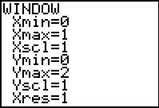
- How does the path of the pancake compare to the graph shown?

Graph the given equation. Press  to explore the function. As you trace, ordered pairs will appear that represent a time in seconds, and the height of the pancake above the griddle at that time.
- Record several ordered pairs here: (you should round to the nearest tenth)
Time (sec) | Height (cm)

- Use the Maximum feature under   to find the maximum height of the pancake, and when it occurs. Enter a left bound, press , enter a right, bound, press , give a guess and press  again.
Time (sec): _______ Maximum height (cm): _______

- At what time does the pancake land on the hot griddle? Where is this on the graph? Use the Zero feature under   to approximate the point when the pancake lands.
Time (sec): _______ Height (cm): _______ (sizzle…Yum!)

- The pancake graph is a parabola because “what goes up must come down.” True or false?

Homework Problem – Soccer Ball
A soccer player kicks a soccer ball into a goal with the following equation, y(x) = –16x²+18x, where x = time (sec) and y(x) = height (ft).  This time, the height of the object is measured in feet and time is still measured in seconds.  Repeat the procedure in Problem 3, graph the equation, and use the  and Maximum features to answer the following questions.  - Time (sec): 0.2 sec Height (ft): _______  - Time: _______ Maximum height (ft): ______ | 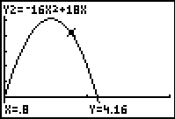  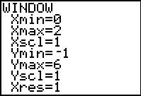
- Time: _______ Height: 0 ft. (ball lands on the ground, perhaps inside the goal net!)

- The soccer ball flies toward a goal that is 6 feet high. Could the ball go over the top bar of the goal?

Extensions
- Two different equations were introduced that actually have the effect of “gravity” built into them. In the pancake problem, the equation contains –4.9x², and in the soccer problem, the equation contains –16x². Investigate why there are two different numbers used in these equations. You may need to search for information about “acceleration due to gravity” on the internet in order to answer.

- Explain the entire formula for projectile motion: h(t) = –0.5gt² + v₀t + h₀. Your previous answer will help to explain the variable “g” in the formula.

- Write your own projectile motion problem using g = 32, initial velocity of 28 ft/sec and an initial height of 3 ft. Choose an object to be launched, and graph the equation. Make sure the window shows the parabola in the first quadrant so that you can see both the maximum (vertex) and where the parabola intersects the x-axis. Explain the meaning of the vertex and the x-intercept. Find several heights at different times.

