Problem 1 – Coin Toss Simulation: Exponential Decay
Imagine you have a bag full of many coins. You pour the coins out of the bag onto a table. All of the coins that land heads up are set aside. The remaining coins are returned to the bag. Then the bag is shaken up and poured out again. Again the coins that land heads up are set aside, and the remaining coins are returned to the bag. The experiment is repeated until there are no coins left in the bag.
How many coins would you expect to be in the bag after 2 trials? After 5 trials?
Let’s simulate this experiment. You can simulate pouring 8 coins out of the bag using the randInt( command. A 0 or a 1 will be randomly chosen 8 times.  - 0 = a coin landing heads up  - 1 = a coin landing tails up | 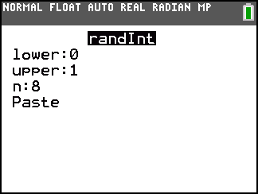
1. How many coins landed heads up? How many coins go back in the bag?

Repeat the simulation, replacing 8 with the number of coins that went back in the bag. Continue to repeat the simulation.
2. How many times is the experiment run until zero coins land tails up (no coins in the bag)? Compare this answer with your partner or other students in the class.

The program COINSIM1 simulates this experiment for a larger number of coins. Press p and choose COINSIM1.  Enter a large number of coins (100 < N < 999) next to N=?. | 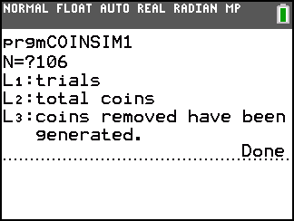
The results are recorded in the lists.  - The trials are numbered in L1.  - The total number of coins poured out of the bag in each trial is given in L2.  - The number of coins removed in each trial is given in L3. | 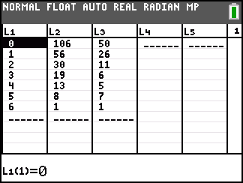
3. Press S e to view the lists. How can you check that the simulation was executed correctly?

View the data as a scatter plot. Press ` å and select Plot1. Match the settings shown.  Press # and select ZoomStat to view the graph. | 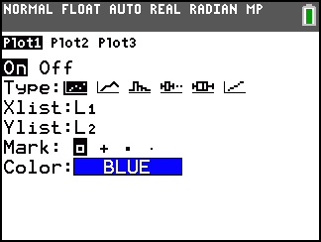
Next you will create an exponential model of the form, y = a∗b^{x}, for this data where a is the initial value and b is the multiplier.  In this case, the value of a is easy to determine: it is the number of coins, n, that you chose to start with.  4. What is the value of a? Store this value as A by pressing = a [A]. | 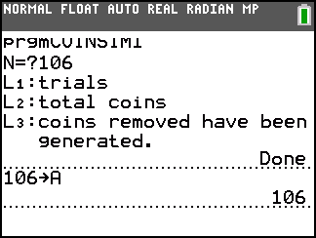
The value of b is equal to the average of the ratios of the number of coins in the bag on a given trial to the number of coins in the bag on the trial before that.  In other words, if T trials were performed, and n_{i} is the number of coins in the bag for trial i,  $b=\frac{1}{T}\sum_{i=0}^{T−1}{\frac{n_{i+1}}{n_{i}}}$. | 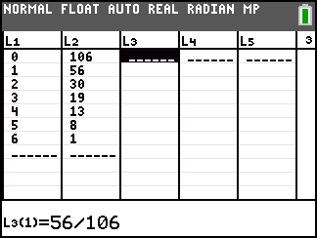
- Start by calculating the ratios $\frac{n_{i+1}}{n_{i}}$. Clear the data from L3.
- In the first cell of L3, divide n₁ by n₀, as shown above.
- Continue to compute the rest of the ratios. (You will have one less ratio than number of trials.)
To find the average of the ratios in L3, use the Mean command, found pressing ` ò and move to the MATH menu.  5. What is the value of b? Store this value as B. | 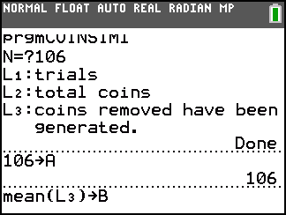
Now, graph your model. Press ! and enter A…B^{X}  6. How well does this function model the data? If it does not fit well, adjust b until you have a good fit.  a. Is this a growth or decay model? How do you know?  b. About what percent of the coins are removed in each trial? | 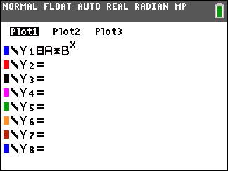
c. Where does the value of b come from?

Now check your model by performing an exponential regression. Press S, move to the CALC menu, and select ExpReg.  The command shown performs the regression and stores the resulting equation in Y2. | 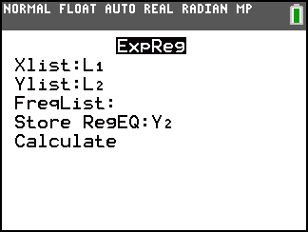
7. How do the values of a and b in the exponential regression compare with those of your model?

8. How well does the exponential regression fit the data? Describe how you know.

Suppose you started with a bag of 100 coins. You want to know how many times you would have to repeat the experiment before less than 50 coins is left. In other words, given a number of coins, how many trials does it take to achieve that number or fewer coins in the bag?

A function that answers this type of question is the inverse of the function you just created. Instead of entering the number of trials and getting the number of coins in the bag as an output, you need to enter the number of coins in the bag and get the number of trials as an output.
To find the inverse of a function, switch the x and y coordinates of the points. This can be done with the scatter plot of this data.  - Delete functions Y2. Turn Plot1 off.  - In the Plot2 settings, switch the XList and YList.  - Press # and select ZoomStat to view the plot. | 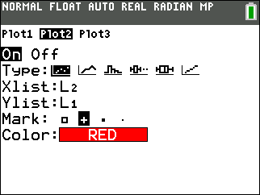
9. What about the model you created? To find its inverse, switch the x and y algebraically:
y = ab^{x} → x = ab^{y}
To solve the new equation for y, divide both sides by a, then take the log of both sides. By applying exponent rules, you should be able to isolate y on one side.

To check your function, graph it in Y2.
This function is a model of the experiment just as much as the exponential model. It is the same data, viewed “from another perspective.”
10. How well does the log function model the data?

What does it mean graphically for two functions to be inverses?
- Graph two scatter plots together. Have both Plot1 & Plot2 on.
  - Plot1: use L1 as the XList and L2 as the YList
  - Plot2: use L2 as the XList and L1 as the YList.
Choose a different Mark to distinguish it from Plot1.
- Select ZoomStat to view the graph. Because of the scale it may be difficult to see the relationship. Use ZoomBox to create a region to zoom into near the origin.  11. What do you notice about the two sets of data?  12. Imagine if you drew a vertical line through each point in Plot1 and a horizontal line through each point in Plot2. (It may help to have the GridLine turned on. Do this with ` # Format.)  a. Where do you think these lines would cross? | Sketch the graph.  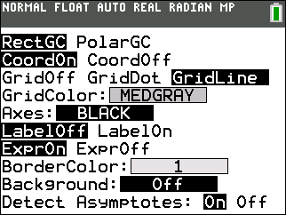
b. What line could you draw between the two data sets so that one data set was the reflection of the other over that line?

Test your answer to question 12b by graphing the equation of the line in Y3.
Problem 2 – Coin Toss Simulation: Exponential Growth
In this problem, you will repeat the exploration and modeling process you used in Problem 1 with a different coin experiment.
You have only a few coins in a bag and pour the coins out. This time, you count the coins that land heads up and add that many new coins to the bag. Now you have the coins that you started with and the new coins in the bag. You shake the bag and pour it out. The experiment is repeated until there are at least 200 coins in the bag.
How many coins would you expect to be in the bag after 2 trials? After 5 trials?
Let’s simulate this experiment. You can simulate pouring 2 coins out of the bag using the randInt( command. A 0 or a 1 will be randomly chosen 2 times.  - 0 = a coin landing heads up  - 1 = a coin landing tails up | 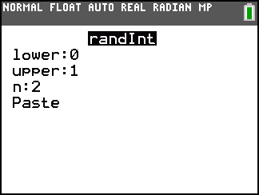
13. How many coins landed heads up? How many coins are placed in the bag?

Repeat the simulation, replacing 2 with the number of coins that were placed in the bag. Continue repeating the simulation.
14. How many times do you have to run the experiment until you have at least 20 coins in the bag? Compare this answer with your partner or other students in the class.

The program COINSIM2 simulates this experiment for a larger number of coins. Press p and choose COINSIM2.  Enter a small number of coins (1< N < 10) next to N=?. | 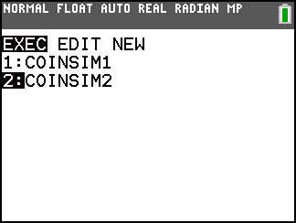
The results are recorded in the lists.  - The trials are numbered in L1.  - The number of coins poured out of the bag in each trial is in L2.  - The number of coins added in each trial is in L3.  Press S e e to view the lists. | 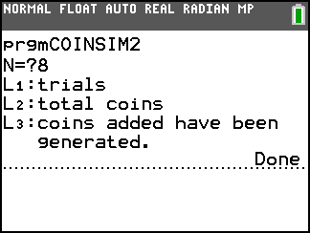
Use the same method as used in Problem 1 to answer the questions below.
View trials vs. number of coins in the bag as a scatter plot. Create an exponential model of the form y = ab^{x} for this data where a is the initial value and b is the multiplier.
15. What are your values of a and b?

Graph your model.
16. a. How well does this function model the data? If it does not fit well, adjust b until you have a good fit.
b. Is this a growth or decay model?

17. About what percent of the coins in the bag in one trial are in the bag in the next trial?

18. Where does the value of b come from?

Check your model by performing an exponential regression on this data set
19. a. How do the values of a and b in the exponential regression compare with those of your model?

b. How well does the exponential regression fit the data?

Switch the XList and YList in the settings for your scatter plot to view the inverse data.
20. Use algebra to find the inverse of the model you created by finding a and b. Record it here.

Check your function by graphing it in Y1.
21. How well does the log function model the data?

Graph the original data and the inverse data together.
22. What do you notice about the two sets of data?

23. Imagine if you drew a vertical line through each point in Plot1 and a horizontal line through each point in Plot2.
a. Where do you think these lines would cross?

b. What line could you draw between the two data sets so that one data set was the reflection of the other over that line?

Test your answer to Question 23b by graphing the equation of the line in Y1.
24. How was the difference between the two experiments (removing vs. adding coins) represented in their exponential and logarithmic models?

