Part 1 – Estimating Length
Take the piece of string home that is provided by your teacher. Use it to mark off this distance at home. Ask 5 people to estimate the length. Give each person a time limit. They are not allowed to walk or attempt to measure the distance.
1. Distance to measure off (given by teacher):
2. Estimate made by each person:

3. Record the whole class list.
4. Create a histogram of the whole class data set. Make sure it shows the minimum, maximum, and all data values in between.  Press ` å to set up the plot as shown.. Press # and choose 9:ZoomStat. | 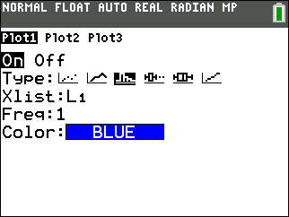
5. Draw the histogram at the right. Show the scale and labels.  6. What does the shape of the graph tells us about people’s estimating skills? | 
7. How do people’s guesses compare with the actual distance?

8. How might this graph look if significantly more people participated?

9. What is another source of data that might have a similarly shaped graph?

Part 2 – Remembering Numbers
In this problem, you will see how many numbers people can remember.
10. Find four people to participate in a memory test. For each person, read the first 2 digits on the list and ask them to repeat them. Record the number correct repeated in the table. Then, read the next 3 digits on the list, ask them to repeat them, and record the number correct. Repeat this process until you have read 12 digits in a row to them and they have repeated the digits.
11. Average each row of responses. Press S and select 1:Edit…. Enter the first and last columns of the table in L1 and L2.
Number of Digits (L1) | Person 1  # Correct | Person 2  # correct | Person 3  # correct | Person 4  # correct | Average Correct (L2)
2
3
4
5
6
7
8
9
10
11
12

12. Create a scatter plot of the data in L1 and L2. Sketch the graph to the right. Show the scale and labels.
13. How is the overall shape of this graph different from the one in Problem 1?

14. Is the graph predictable? Are there any conclusions you can draw from this experiment?

15. Do you think there’s a limit to how many numbers a typical person can remember? Explain.

