How Cool It Is!  ID: 12147 | Time Required  15-20 minutes

Activity Overview
In this activity, students will use a temperature probe to generate a cooling curve and develop an appropriate regression equation to model collected data.

Topic: Cooling & Heating Curves
- Exponential Regression
- Data Analysis
- Data Collection with Probeware

Teacher Preparation and Notes
- This activity was designed for use with Vernier Easy Link temperature probes. Please note that an Easy Link adapter will be necessary if the probes to be used do not have a mini USB link.
- The Easy Data application may be downloaded from the education.ti.com website in the downloads section.
- Problem 1 involves generating data using ice cubes and water that is slightly warm. Make certain that the cups or containers used are large enough to accommodate adding ice and stirring of contents. It will be necessary for students to work in pairs or small groups so that one may start the data sampling while another student drops ice into the water and stirs. Problem 2 is a related problem involving heating of water. If time allows, the teacher may choose to use hot plates and have students generate unique heating curves. Data is provided in the lists L1 and L2 for this problem should time not allow for generation of data.
- To download the student worksheet and data files, go to education.ti.com/exchange and enter 12147” in the quick search box.

Associated Materials
- PrecalcWeek19_HowCool_worksheet_TI84.doc
- L1 and L2 data files

Suggested Related Activities
To download any activity listed, go to education.ti.com/exchange and enter the number in the quick search box.
- Exploring the Exponential Function (TI-84 Plus family) — 5653
- Half-Life (TI-84 Plus family) — 9287
- The King’s Chessboard (TI-84 Plus family with TI-Navigator) — 9366

Problem 1 – Cooling Curve
Students are to drop 6 standard sized ice cubes into approximately 1 cup of tepid or lukewarm water.  It is recommended that the teacher test this to ahead of time to ensure that the ice cubes do not melt too quickly as temperature changes are to be recorded over a 2 minute period. The ice should last to the very end of the 2 minute period.  The EasyData application automatically stores the data from the experiment in L1 and L2 and automatically creates a scatterplot of the data being gathered. |  | 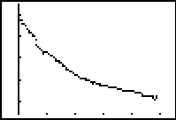  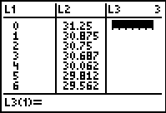
Note: Do not use the Anlyz button of the EasyData App to do the regression.
Students are quit the application and use the ExpReg command from the CALC menu to find a regression equation for the data. After calculating the equation and setting up Plot1 (as shown below), students can press # and select ZoomStat. They should see that the equation does not fit the data very well.
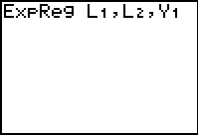 | 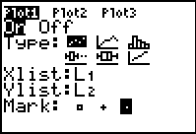 |  | 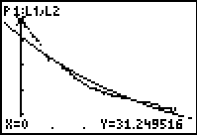
Much exploration is done in the rest of the activity to obtain an equation that best models the given data. Students use regression models as well as the transformation graphing application to adjust values of a, b, and c in the development of an exponential equation of the form f(x) = ab^{x} + c.
Several questions are asked throughout the activity to guide students in the development of an equation to best model the generated data.
Discuss with students how the apparent horizontal asymptote relates to the exponential equation form f(x) = ab^{x} + c. Ask the students what limitations the TI-84 has in regard to the exponential regression performed. This will be helpful in providing clarification for the need to adjust the data in obtaining the second regression equation. The regression equation obtained with the TI-84 is of the form f(x) = ab^{x}. A vertical shift is not taken into account.
For the second regression equation, students will generate a second set of temperature data in the spreadsheet. In the formula bar of L3, students are to subtract a value from L2.  Students are then to perform an exponential regression on the newly created data and compare it to the original regression equation. |  | 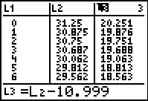
Students will graph the original data (NOT the adjusted data) as a scatter plot.  They will also graph 3 equations: (1) the original regression equation, (2) the adjusted data regression equation, and (3) the adjusted data regression equation + the value they subtracted in the spreadsheet.  Students may need to view the regression equations separately. In the screenshot at the right, equation 3 and the scatter plot are graphed. |  | 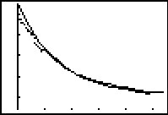
In conclusion to the first part of the activity, students will use Transformation Graphing application to find their own regression equations. Discuss with students which equation best fits the data and why.  Note: It will be necessary to uninstall the Transformation Graphing application now by pressing A, selecting Transfrm and choosing Uninstall. |  | 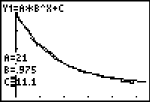
Problem 2 – Heating Curve
Students may either generate their own data or use the data provided. If Students generate their own data, hot plates and glass cups will be needed. Again, students explore regression equations and apply the use of the transformational graphing application to find an equation to best fit the given data.
This problem provides students with an opportunity to practice and apply what was learned in Problem 1.
Students will need to clear all existing data from the lists before beginning this problem.

Solutions – Student Worksheet
1. exponential
2. Result depends upon student data (should be close to f(x) = 25(0.99)^{x}.)
3. no
4. adjust for the vertical shift, or apparent horizontal asymptote/test values for a, b, and c in
5. answer should be yes, for the solution data, this line appears to be near y = 11
6. for the solution data, the equation is roughly
7. Answers will vary, but the values of r should be very close
8. The adjusted regression equation provides a much better fit visually.
9. test values for a, b, and c in
10. Students should that or an equation close to this one works well. If the first few seconds of data are disregarded, this equation provides a very good fit. All 3 regression equations are relatively close, but the 2nd and 3rd regression equations are closest and provide the best fitting models. The 2nd and 3rd equations only show a very significant difference in the value of a.
11. Our impatience seems to lead us to feel that drinks that are too hot cool slowly in reaching a drinkable temperature. The most dramatic temperature change occurs at the start of the experiment, when temperature is highest.
12.
13. This equation seems to fit the data reasonably well
14. It appears that this graph may have a horizontal asymptote, possibly around y = 9.
15.
16. For the first regression, r ≈ 0.99, and for the second regression, r ≈ 0.94, indicating that the first regression provides a better fit. This will vary depending upon the apparent horizontal asymptote chosen by the student for obtaining the second regression equation.
17. This answer may vary depending upon the apparent horizontal asymptote chosen. The work shown on the solution file indicates the best fit with the first regression equation.
18.

