Part 1 – The Same Name Game
Find four fractions that are equivalent to the given decimal.
1. 0.25  2. 0.75 |  | To convert a decimal to a fraction, press . 2 5 a ∏ 4 . Pressing e will display the result.  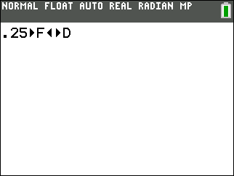
3. 0.6 |  | 4. 0.45
5. With a partner, write two different stories that use two equivalent fractions. Explain why the different fractions make more sense in your story.

Place the equivalent fractions in groups.
6. , , , , , , , , , ,  7. ,, , , , , , , , , |  |  |  | To reduce a fraction, make sure the Mode is set to MathPrint, enter the fraction, then press .  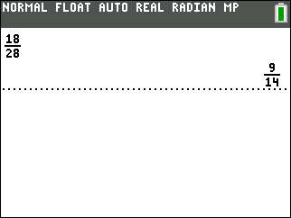
Part 2 – Greater Than or Less Than
Find a fraction that meets each of the given conditions. Use the a ∏ 4 feature to help you find the needed fractions.
8. Greater than 0, Less than 0.25  Answer: |  | 9. Less than 0  Answer:
10. Greater than 1  Answer: |  | 11. Greater than 0.25 and Less than 0.30  Answer:
12. Between and  Answer: |  | 13. Greater than and less than  Answer:
Part 3 – Visually Find Equivalent Fractions
Write 2 equivalent fractions that are shown in each diagram.
14. | Answer: | 15. | Answer:
16.

Answer:

