Factoring Special Cases  ID: 9604 | Time required  30 minutes

Activity Overview
In this activity, students explore geometric proofs for two factoring rules: a² + 2ab + b² = (a + b)² and x² - a² = (x - a) (x + a). Given a set of shapes whose combined areas represent the left-hand expression, they manipulate them to create rectangles whose areas are equal to the right-hand expression.
Topic: Quadratic Functions and Equations
- Express a trinomial square of the form a²+2ab + b² as the binomial squared (a+b)².
- Express a difference of squares of the form x² – a² as (x – a) (x + a) and display as a difference of areas.

Teacher Preparation
This activity is appropriate for students in Algebra 1. Prior to beginning this activity, students should be familiar with factoring quadratic expressions. The activity should be followed by practice applying the rules discussed.
- This activity is designed to be performed by individual students or small groups with teacher assistance. By using the computer software and the questions found in this document, you can lead an interactive class discussion on solving quadratic equations.
- This activity requires students to drag, rotate, and hide objects in CabriJr. If students are not familiar with these functions of the CabriJr, extra time should be taken to explain them.
- To download the CabriJr files FACTOR1 – 3, go to education.ti.com/exchange and enter “9604” in the keyword search box.

Associated Materials
- FactoringSpecialCases_Student.doc
- FACTOR1.8xv, FACTOR2.8xv, FACTOR3.8xv (Cabri Jr. files))

Suggested Related Activities
To download any activity listed, go to education.ti.com/exchange and enter the number in the keyword search box.
- Solve Square Root Equation (TI-84 Plus family Study Cards) — 1643
- Radical Transformations (TI-84 Plus family) — 11574
- Braking and Total Stopping Distances (TI-84 Plus family with TI-Navigator) — 5617

Problem 1 – Factoring a perfect-square trinomial
Any trinomial of the form a² + 2ab + b² is a perfect-square trinomial. If you recognize a perfect-square trinomial, you can factor it immediately as (a + b)².  Students will use the Cabri Jr file FACTOR1, to see why a² + 2ab + b² = (a + b)². | 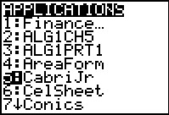
They need to start the CabriJr app by pressing the A button and choosing it from the menu. Then, open the file FACTOR1 by pressing ! to open the F1: File menu, choosing Open, and choosing it from the list. | 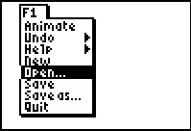
Students will see two squares and two rectangles, with the dimensions labeled with either an A or a B.  The areas of the shapes are A², AB, B², and AB. | 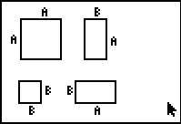
Students are directed to arrange the shapes to form a square. To move a shape, they need to move the cursor over a shape (so that the entire shape becomes a moving dashed line) and press a to grab it, and then move it with the arrow keys. When the shape is positioned where they want it, press e to let it go. | 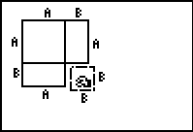
They should see that the area of the large square is A² + AB + B² + AB. The length of one side is A + B and so the area of the square is (A + B)².  Explain to students that the shapes have shown that the area of this square is equal to a² + 2ab + b² and also equal to (a + b)².  Therefore a² + 2ab + b² = (a + b)². | 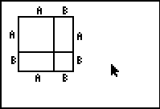

Problem 2 - Factoring a difference of squares
Any trinomial of the form m² – n² is a difference of squares. If you recognize a difference of squares, you can factor it immediately as (m + n)(m – n).
Students will use the Cabri Jr. file FACTOR2 to see why m² – n² = (m + n)(m – n).
To open the file, students need to press ! to open then F1: File menu, choose Open, and then choose it from the list.
FACTOR2 shows two squares with the dimensions labeled with M or N.  Students should see that the area of the large square is M² and the area of the small square is N². | 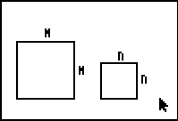
Students are directed to move the N² square on top of the M² square so that their corners align. Explain to students that “cutting” the smaller square out of the larger square, the L-shaped area that remains is equal to m² – n². | 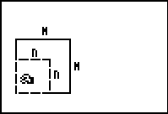
Now students will use FACTOR3 to prove the area of the L-shape is m² – n². Students will take it apart and rearrange the pieces into a single long rectangle.  FACTOR3, shows the same shapes as FACTOR2, but with the L-shaped area (m² – n²) divided into two rectangles. | 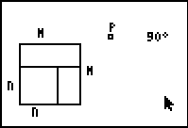
Students need to rotate the smaller rectangle about point P (at the top of the screen) clockwise 90°.  To do this, they need to press $ to open the F4: Transform menu and choose Rotation. Move the cursor over the rectangle to highlight it and press e to choose it. Then move the cursor to the point you want to rotate around (P) and press e. Finally, mark the angle of rotation by moving to 90° and pressing e. | 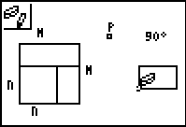
The Rotation tool will produce a duplicate rectangle. Students need to hide the original small rectangle and the vertices of the rotated image.  To do this, press % to open the F5: Appearance menu and choose Hide/Show > Objects. Press  when the rectangle and vertices are each highlighted. | 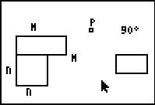
Now students are directed to move the larger rectangle (the small rectangle cannot be moved) alongside the rotated image to form one long rectangle. Now students should see two rectangles whose combined area is equal to the area of the original L-shape.  The dimensions of the combined rectangle is (M – N), the short side, by (M + N), the long side. | 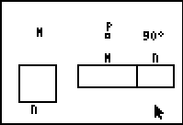
Students should now use for the area of a rectangle to find the area of the rectangle.
A = lw = (m + n)(m – n) = m² – mn + mn – n² = m² – n²
They have now proved the rule for factoring a difference of squares!

