Problem 1 – Finding the Area between Two Given Scores
On a certain test, the scores are normally distributed with a mean of 76 and a standard deviation of 7.  Graph the normal distribution by pressing o and entering normalpdf(X, 76, 7). The normalpdf command is in the DISTR menu which is accessed by pressing y½.  After entering the values, select Paste to transfer the information to the Y= screen.  Press p and set the values equal to the following.  Xmin = 40, Xmax = 120, Xscl = 7, Ymin = 0,  Ymax = 0.1, Yscl = 0 | 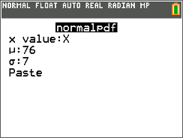
Draw the vertical line x = 80 by pressing y¼ and choosing Vertical. Use the arrow keys to place the line as needed. | 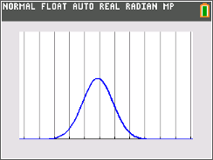
You may wish to change the default color, blue, of the vertical line to some other color like red to contrast it with the default color of the Y1 graph. To change the color, press s. | 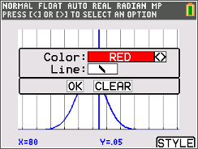  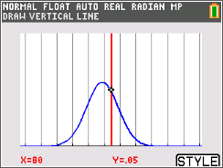
1. Estimate the proportion of scores that fall below 80; that is, the area under the curve and to the left of the vertical line. Explain how you chose your answer.
Press y z to quit. Check your estimate by choosing normalcdf from the DISTR menu. Enter the lower bound, the upper bound, the mean, and the standard deviation.  The lower bound is negative infinity: use –1 × 10⁹⁹, entered as –1E99. To type E, press y¢. | 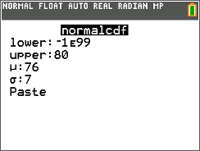
2. What is the actual proportion of scores that are less than 80? Round to the nearest thousandth.

See the area shaded on the curve by pressing y½, arrowing over to the DRAW menu, choosing ShadeNorm( and entering the lower bound, upper bound, mean, and standard deviation as before. Then selecting Draw.  Press y¼ and choose ClrDraw to remove the shading from under the normal curve. Press DRAW again to draw a vertical line at about x = 60. | 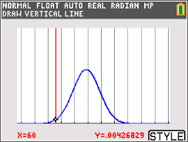
3. Estimate the proportion of scores that fall below 60. Explain how you chose your answer.  4. Find the actual proportion by using either normalcdf or ShadeNorm. Round to the nearest thousandth. | 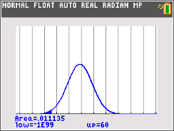
5. Subtract the area that is below 60 from the area that is below 80.

Confirm that this is the proportion of scores that fall between 60 and 80 by using the normalcdf command with 60 as the lower bound and 80 as the upper bound.
Problem 2 – Finding the Area Greater than a Given Value
The weights of game tokens are normally distributed with a mean of 4.85 grams and a standard deviation of 0.08 gram.
6. How can you use the normalcdf command to find the probability that a randomly chosen token weighs more than 4.9 grams if normalcdf gives the area to the left of a value, rather than to the right of a value?

7. Use normalcdf to find P(weight > 4.9 g). Round to the nearest thousandth.

8. Estimate P(weight > 4.75). Explain how you chose your answer.

9. Use normalcdf to find P(weight > 4.75 g). Round to the nearest thousandth.

Problem 3 – Using the Standard Normal Distribution
The standard normal distribution has a mean of 0 and a standard deviation of 1. Change Y1 to graph the standard normal distribution. Set your window settings as follows:  Xmin = –4, Xmax = 4, Xscl = 1, Ymin = 0,  Ymax = 0.5, Yscl = 0 | 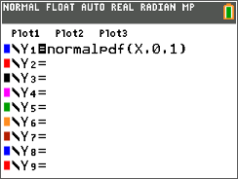
A z-score gives the number of standard deviations above or below the mean of a standard normal distribution: | 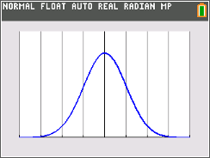
The scores on an IQ test are normally distributed with a mean of 100 and a standard deviation of 15. A student scored an 88.
10. What is the student’s z-score?
11. Use what you know about normal curves to explain why the value is negative and why the absolute value of the score is less than one.

Check that the z-score you found above is correct by finding the area to the left of it for a normal distribution with a mean of 0 and a standard deviation of 1 and then finding the area to the left of 88 for a normal distribution with a mean of 100 and a standard deviation of 15. | 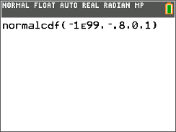
12. What are these areas? Round to the nearest thousandth.

13. A student has a z-score of 2.8. What was their score on the test? Tell how you found the answer.

Check that the z-score you found above is correct by comparing the probabilities that a z-score is less than 2.8 and that a test score is less than the score you found.

14. What are these areas? Round to the nearest thousandth.
15. Find P(–1.5 < z < 2.3). Round to the nearest thousandth.
16. In what range of test scores does P(–1.5 < z < 2.3) correspond with?

