Open the TI-Nspire document Solving_Exponential_Equations.tns.  We know that and, but is there an approximate solution to the equation? An exact solution? In this activity, you will explore the answer to these questions numerically, graphically, and algebraically. | 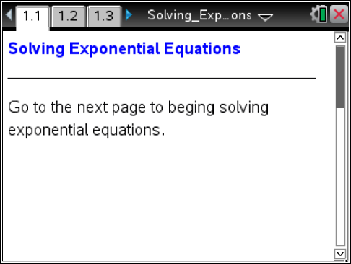

1. Estimate the solution to the equationusing the following numeric pattern:

Move to page 1.2.

2. The table shows inputs and outputs for the function.

a. Input your estimate from question 1 by entering it into cell A2. Input other values to get the output as close as possible to 3. Record your closest input and output below:

b. Is there an input value that results in an output value of exactly 3? Why or why not?

Move to page 1.3.

3. The graph of the functionis shown along with its inverse. Point is the reflection of point P over the line.

a. Suppose the coordinates of P are. Write a logarithmic equation by substituting the coordinates of into the function.

b. Move point P’ so that the input of the function is 3. According to the graph, what is the approximate solution to the equation? Why is this an approximate solution?

c. Recall that the composition of any function and its inverse always results in x. In other words, . As such, the composition of and results in the equation. Use this composition relationship to find the exact solution to the equation. What is the exact solution?

Move to page 2.1.

4. Solve the equation by changing the base and reducing the left side of the equation to x. To change the base, click the up and down arrow. How do you find the exact solution using this algebraic method?

Move to page 2.2.

5. In questions 1 and 2 you found approximate solutions to the equation using numeric methods. You found exact solutions using graphical methods in Question 3 and algebraic methods in question 4. Determine how close your estimates were by entering your exact answers in the Calculator page found on page 2.2. Do all methods produce equivalent solutions?

6. Estimate the solution to the equationusing the following numeric pattern:

Move to page 3.1.

7. The table shows inputs and outputs for the function. Input your estimate from question 6 by entering it into cell A2. Input other values to get the output as close as possible to 7. Record your closest input and output below:

Move to page 3.2.

8. The graph of the functionis shown along with its inverse. Point is the reflection of point P over the line. Move point P’ so that the input of the function is 7. According to the graph, what is the approximate solution to the equation?

Move to page 4.1.

9. Solve the equation by changing the base and reducing the left side of the equation to x. To change the base, click the up and down arrow. How do you find the exact solution using this algebraic method?

Move to page 4.2.

10. Determine how close your estimates from questions 7 and 8 were by entering your exact answer from question 9 in this Calculator page. Do all methods produce equivalent solutions?

11. Use the algebraic method from questions 4 and 9 to find exact solutions to these equations.

a.

b.

c.

