Open the TI-Nspire document Exponential_vs_Power.tns.  This activity explores differences between the exponential function and the power function , where a is a positive integer greater than 1. | 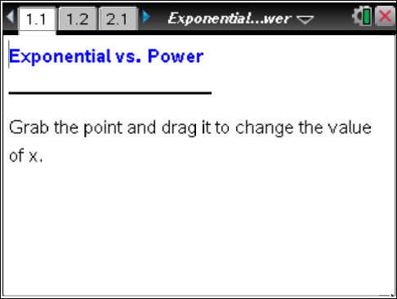

Move to page 1.2. | Press / ¢ and / ¡ to navigate through the lesson.
1. Compare the functions and when a = 2 by dragging point x along the number line.
a. As x increases, which function appears to grow faster?

b. For what x-values, if any, are the functions 2^{x} and x² equal?

2. Explore several different a-values using ∆ and ∇. As you do so, continue to drag point x along the number line.
a. As x increases, does the exponential function or the power function appear to grow faster?

b. For what x-values, if any, are the functions equal? Summarize your results in the table below.

Base | x-values
2
3
4
5

Move to page 2.1.
3. Drag the point x on the arrow to the right to produce two graphs, one solid and one dashed.
a. Identify which graph represents the exponential function and which graph represents the power function . Justify your answer.

b. As x increases, does the exponential function or the power function appear to grow faster?

c. For what x-values, if any, are the functions equal?

d. Are there any other x-values for which the two functions are equal?

4. Explore several different a-values using ∆ and ∇. As you do so, continue to drag point x along the number line.
a. Complete the table below for x > 0.

a | Interval(s) where | Interval(s) where
2
3
4
5

b. In general, for large values of x, which increases faster: an exponential function or a power function?

5. You plan to invest money for x number of years. You get to choose whether your interest is calculated using the function or . Which would you choose and why?

