Part 1 – A 20% Discount
Your favorite sporting goods store is having a sale. Use your TI-84 Plus calculator to create a table that displays the discount and sale price for items originally costing $20, $30, $40, etc., up to $100 for a sale when all items are reduced by 20%.
1. Using the TI-84 home screen, make a table for the 20 percent off sale. You can enter percent calculations in various ways. These are shown for $30 at the right.

Original Price | 20% off Discount | Sale Price
$20
$30
$40
$50
$60
$70
$80
$90
$100
x
(any original price)

2. Write an equation for the amount of the discount.
3. Write an equation for the sale price after the discount.
4. Use the TI-84 Plus table feature to make a table for the 20 percent off sale. Enter the “amount of discount” equation in Y1 and the “sale price” equation in Y2. Press e to enter the equations.  Then press ` ç and enter the settings at the right to set up the table.  Then press `ê to view the table. | 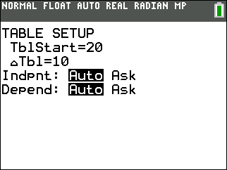
5. What would the discount be for an item that was originally $40?
6. What would the sale price be for an item that was originally $60?
7. What was the original price for an item that is $72 during the sale?
8. How can you find the sale price for an item that originally cost $25?

9. How can you find the sale price for an item that originally cost $42?

Part 2 – The Sale Gets Greater
10. Now make a table for a 40% off sale.
Original Price | 40% off Discount | Sale Price
$20
$30
$40
$50
$60
$70
$80
$90
$100
x
(any original price)

11. How did you change the original equations (Y1 and Y2) to create the second table?

12. What would the discount be for an item that was originally $40?
13. What would the sale price be for an item that was originally $60?
14. What was the original price for an item that is $72 during the sale?
15. How can you find the sale price for an item that originally cost $25?

16. Suppose you have $24.50 to spend. Find the original price for the most expensive item you can afford during the 40% off sale.
17. Write a one-step rule to find the sale price for any item during a 40% off sale, using x as the original price.

