Open the TI-Nspire document Systems_of_Linear_Inequalities_1.tns.  The solution set for a system of linear inequalities is the set of ordered pairs that satisfy that system. This activity gives you a visual way of thinking about the solution set to a system of linear inequalities. | 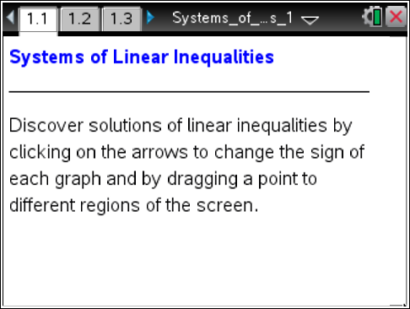

Move to page 1.2.

1. Page 1.2 is a review of finding a solution set to one linear inequality. Move the point around and notice when the word true or false appears. What do these words refer to in this context?

2. Select another inequality symbol by clicking on the up or down arrows. Now move the point to a location where this inequality is true. Verify that the coordinates make the inequality a true statement. This point is said to satisfy the inequality.

3. Click the arrows to change the inequality to ≤ and then to ≥. What points satisfy these new inequalities that did not satisfy the inequalities in question 2?

Move to page 1.3.

4. Two equations are currently graphed dividing the plane into four regions. Drag the point until “The Solution” shows and both equations display “True.” Because there is no shading yet, what does “The Solution” indicate?

5. Click the top set of arrows until y ≤ x + 3 is displayed. Click the bottom set of arrows until y > –x – 1 is displayed. Test the point by dragging it into all regions. Complete the table.
Regions | Point | y ≤ x + 3  (True or False) | y > –x – 1  (True or False)
Left
Right
Top
Bottom
6. Describe the solution set in which both inequalities are true.

Move to page 2.1.

7. a. Again, the equations have divided the plane into four regions. How would you change the inequality symbols so the top region contains the solution set with two dotted boundary lines? What would the inequalities be that have this solution? Algebraically verify your test point here.

b. What happens to the test point when it is moved to a boundary line?

Move to page 3.1.

8. Click the arrows until the bottom region contains the solution set with two solid boundary lines. What are the inequalities that you found? Algebraically verify your test point here.

9. What happens to the test point when it is moved to a boundary line?

Move to page 4.1.

10. Explain why there is a horizontal line.

11. How would you change the inequalities so that the bottom-right region is the solution set? What inequalities would have this solution set? Algebraically verify your test point here.

Move to page 5.1.

12. Explain why the lines are parallel.

13. What inequalities would need to be used to have NO solution set?

Move to page 6.1.

14. The inequalities are not given on this page. Determine the inequalities that determine the solution set. Algebraically verify your test point.

15. Why must you use both inequalities to check a point in the solution region?

