System 1
Press □. Enter the following equations:  Y1 = 3 + 0.5X  Y2 = –9 + 2X  Press . Set the window as shown at the right.  Press .  - The solution to this system occurs where the two equations are equal. Where does this appear to occur? | 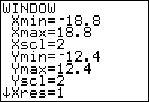
Press . You will be tracing on the function Y1, as indicated in the top left corner of the screen. Use the left and right arrow keys to move the cursor to the point where the two lines appear to intersect.
NOTE: You will notice that the x-values change by 2-tenths as you move the cursor. It appears that the two lines intersect at the point (8, 7).
Press . This will move your cursor to trace on the function Y2.
- What does it mean that the point (8, 7) also exists on this function?

Press   and match the settings as shown at the right.  Next examine the table. Press  . Arrow down to find the x-value that gives the same y-value for both functions.  - What is the x-value? The y-value? | 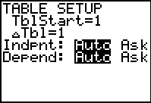
Return to the graph. Use the intersect command (press  ) to find the exact solution. Choose each curve (or line), and then a guess where the intersection point is.

System 2
Press □. Enter the following equations:  Y1 = 7 + 2.5X  Y2 = 35.9 – 6X  Press . Set the window as shown at the right.  Press .  - Estimate where the solution occurs. | 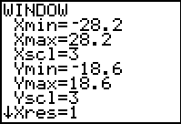
Next examine the table.
- This time you will notice that no x-value gives the same y-value for both functions. However, what happens between x = 3 and x = 4?

It is possible to “zoom in” on this section of the table. Press  . To examine the part of the table between 3 and 4, change the TblStart to 3. You need to count by a smaller amount than 1. Try changing the ΔTbl (change in table) to 0.1.  Press   to return to the table. Notice that the top value of x is 3 and x increases by 0.1 in each row.  - Do you see an x-value that gives the same y-value in each function? If so, what is the x-value? The y-value? | 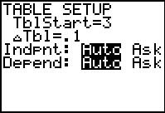
Press  and .
- Try tracing to the x-value you found using the table. What happened?

To jump exactly to your desired x-value, while in Trace mode, type the x-value followed by .
- How does the y-value compare to the one you found using the table?

Use the intersect command (press  ) to find the exact solution.
- What are the coordinates of the solution?

