Finding a Line of Best Fit  ID: 8192 | Name ____________________________
Finding a Line of Best Fit  ID: 8192 | Class ____________________________

In this activity, you will explore:  - Creating a scatter plot representing resting heart rates versus age.  - Graphing vertical and horizontal lines to show Q1 and Q3 for both the ages and the heart rates.  - Using the vertices of the Q1 and Q3 lines to calculate a line of best fit and graph it. | 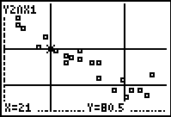
Enter the 21 data points shown in the screens below in the AGE and RHR lists.
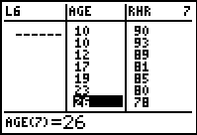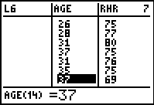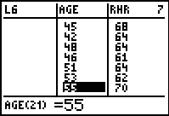
Plot this data as a scatter plot.
- What are Q1 and Q3 of the ages? Graphs these as horizontal lines.

- What are Q1 and Q3 of the heart rates? Graph these as vertical lines.

- Where do these lines intersect? Write the coordinates of the four points.

- Identify the diagonal across the center rectangle that follows the direction of the points. What two intersection points does it connect?

- Use these two points to write the equation for the line that will form the diagonal using the point-slope form.

Graph the equation.

