Living On The Edge  ID: 9409 | Time required  45 minutes

Activity Overview
In this activity, students build a solution to a rather complex problem—finding the edge length of an octahedron given its volume—by solving two simpler problems first. First, they find a formula for the edge length of a square given its area. After testing this formula by comparing points on its graph with the measurements of a model square, they write an equivalent formula with fractional exponents and substitute values to find the edge length of a particular square. This process is repeated to find, test, and apply a formula for the edge length of a cube given its volume. Finally, students solve an equation involving several different radical expressions to find a formula for the edge length of an octahedron given its volume, and use it to solve the original problem.

Topic: Rational & Radical Functions & Equations
- Use technology to verify the equivalence of radical and fractional exponent representations of expressions.
- Graph radical functions and inequalities.
- Evaluate a radical function for any real value of its variable.
- Solve radical equations and inequalities algebraically and check for extraneous roots.

Teacher Preparation and Notes
- Prior to beginning this activity, students should have experience simplifying radical expressions, solving simple radical equations, and applying exponent rules. They should also download the files EDGE1 and EDGE2 to their calculators.
- This activity requires students to graph functions and measure geometric shapes. If students have not had experience with these functions of the graphing calculator, extra time should be taken to explain them.
- To download the Cabri Jr. documents (.8xv files) and student worksheet, go to education.ti.com/exchange and enter “9409” in the keyword search box.

Associated Materials
- LivingOnTheEdge_Student.doc
- EDGE1.8xv
- EDGE2.8xv

Suggested Related Activities
To download any activity listed, go to education.ti.com/exchange and enter the number in the keyword search box.
- Rational Exponents (TI-Nspire technology) — 11594
- Radicals (TI-84 Plus family) —1915

Students are introduced to the concept of this activity: working backwards from the area or volume of a regular shape or solid to find its edge lengths. Review the term regular. Students should understand why a regular shape or solid has only one edge length (unlike a rectangle for example, which has two) before proceeding.
Students are presented with a real-world situation where this concept might be applied.

Problem 1 – Edge length of a square
It is suggested that students first solve a simpler problem involving the area of squares before tackling the problem about the volume of an octahedron. This helps students connect to material with which they are already familiar and reinforces a powerful problem solving strategy.
Students are prompted to solve the formula for the area of a square for its side length, s. Students should remember to include a ± sign in front of the radical when they take the square root. ()
Next, students are reminded that they can drop the ± sign from their formulas since the numbers in this application will be nonnegative. (They all represent length and area measurements.)
Students will graph their function in Y1 to verify that the graph makes sense in the situation. They will then use fractional exponents and re-enter their formula with fractional exponents in Y2 to confirm that it is equivalent to the formula written with the radical sign. | 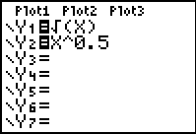
If using Mathprint OS:  When entering the function in Y1 and students press  , the cursor will move under the square root bracket. Press  .  When entering the function in Y2 and students press , the cursor will move to the exponent position. Students should enter the value of the exponent and then press  to move out of the exponent position. Then press . | 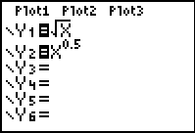
Students measure the side length and area of a model square. They can then compare points on the graph of their function with the side length and area of a model square to confirm the accuracy of their model. | 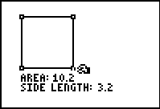
Optionally, you may direct students to graph the original area formula A(s) on this same graph, replacing s with x, to see the inverse relationship between these two functions. | 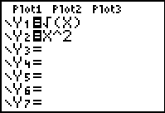
Students evaluate their function for A = 45 on the Home screen, arriving at the solution to the simpler problem  (s = 6.7802 cm).  Remind students that this problem is a “proof of concept:” although all these steps to test the model may seem unnecessary in this simple situation, it is important to make sure that the method used to solve this problem is correct because they will soon be using it in a more complex situation. | 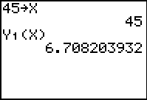
If using Mathprint OS:  Y1 can be entered by pressing   . | 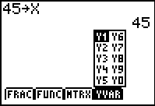
Problem 2 – Edge length of a cube
In this problem, students solve a slightly more complicated problem involving the volume of cubes. Students are given the formula for the volume of a cube and prompted to solve it for the side length, s. Again they test their formula by graphing it alongside a model cube and comparing points on the graph with the measurements of the cube. Students will again rewrite their formula with fractional exponents and establish that it is equivalent to the formula written with radical signs. | 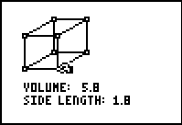
Finally, they evaluate the formula for V = 356 to solve the problem. | 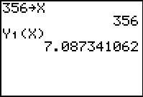

Problem 3 – Edge length of an octahedron
Now students apply what they have learned to solve the original problem. Solving the given volume equation involves manipulating several radical expressions, applying exponent rules, and rationalizing the denominator, as shown.
Rather than graphing and comparing with a model octahedron, students check their algebra by substituting the original expression for V into their equation:
Finally, students evaluate their equation for V = 1,512 to obtain the answer, 14.7475 mm.

