z-score
t-score

Problem 1 – Large Sample, = 0.05
Ten years ago, the mean salary in a certain community was $43,208. An investor thinks it is now higher than that.
In the community, 100 residents are randomly surveyed; the sample mean and standard deviation of this sample are computed.
1. Write null and alternative hypotheses.

2. Will you need to find a z-score or a t-score? Why?

The sample mean and standard deviation from the 100 residents are:
, s = $14,192
3. Calculate the test statistic.  4. Find the critical value by using the invNorm command in the [DISTR] menu. Use a 5% significance level.  5. Do you reject or fail to reject the null hypothesis? Why? |  | 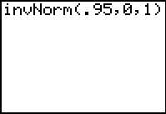
Press  and set the values equal to the following.
Xmin = –5 Xmax = 5 Xscl = 1
Ymin = –0.15 Ymax = 0.45 Yscl = 0.1
The P-value can be found by using the ShadeNorm command. It is located in the DRAW menu which is accessed by pressing  .  The format is lower bound, upper bound, mean, standard deviation. Use –1E99 for negative infinity and 1E99 for positive infinity. (E is typed by pressing [EE].)  6. What is the area to the right of the test statistic?  7. What is the P-value?  8. How does this confirm your decision to either reject or fail to reject the null hypothesis? |  | 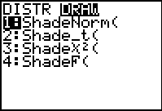  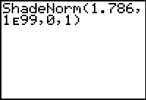
Problem 2 – Large Sample, = 0.01
In Problem 1, the significance level was 5%. Perform the hypothesis test again, this time with a significance level of 1%.
9. What is the new critical value?

10. Do you reject or fail to reject the null hypothesis? Why?

Problem 3 – Small Sample, = 0.05
Suppose that the sample mean and standard deviation ($45,742 and $14,192) came from a sample of 25 residents instead of 100 residents.
11. Will you find a z-score or a t-score? Why?

12. Calculate the test statistic.

13. Calculate the critical value by using the invT command. It is located in the [DISTR] menu, below the invNorm command. The format is area to the left, degrees of freedom.  14. Do you reject or fail to reject the null hypothesis? Why? | 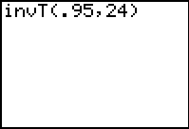
15. What must be true about the P-value? Why?

16. Find the P-value.

Problem 4 – Extension
Press , choose TESTS and select Z-Test or T-Test to find the test statistic and P-value for sample sizes between 25 and 100. Discuss how these values change and why.  Note: For Inpt (the input method), choose Stats. | 