Open the TI-Nspire document Trend_or_Noise.tns.  Do school achievement scores change a lot? In this activity, you will investigate the variability of scores on achievement tests from classroom to classroom and from year to year. | 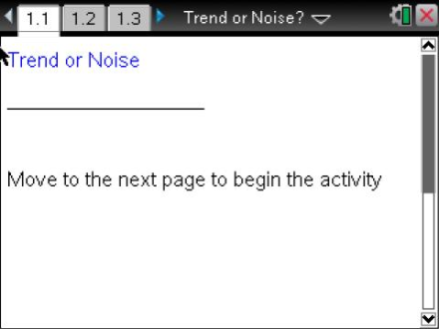

Move to page 1.2. | Press / ¢ and / ¡ to navigate through the lesson.
Page 1.2 gives instructions for seeding the random number generator on the handheld. Page 1.3 is a Calculator page for the seeding process. Carrying out this step will prevent you from generating data identical to your classmates.

Move to page 1.4.

1. a. Use the top arrow in the top work area to display a randomly generated set of mathematics achievement scores for 120 5th grade students at Garfield Elementary School for a given year. Describe the distribution in the dotplot.
Note: Moving the cursor over a point in a dotplot will display the value of that point; moving the cursor over a boxplot will display the five values used to construct the plot.

b. The bottom work area shows the boxplot of the scores. Interpret the interquartile range and what it indicates about the scores for the fifth graders at Garfield.

Move to page 1.5.

The scores are also reported by individual classes. Each class has 20 students, each taught by a different teacher.
2. Examine the boxplots of the scores of the six classes.
a. Do any of the classes seem to have higher achievement scores than the others? Explain your reasoning.

b. Compare the distributions of the classes.

c. Use the shape of the distribution and the median to estimate the mean scores for each of the classes. Fill out the table for each class.

Class | median | Estimated mean | Reasoning about the distribution  to support estimate
C1
C2
C3
C4
C5
C6

d. Suppose the administration had a boxplot of the mean scores for each class. Would you expect to see the whiskers of the boxplot as low as 45, the low score for class1? Why or why not?

Move to page 1.6.

3. The graph in the top work area displays the scores of all the Garfield fifth graders. The graph in the bottom work area displays the set of the mean scores of each of the classes.
a. Remember that class 5 seemed to be different from the other classes. Make a conjecture about the mean of class 5. Explain your reasoning.

b. Make a sketch of the two plots based on the .tns file, indicating the five summary numbers for each.

c. Compare the IQR for the two plots, and explain why they are so different.

d. Why are the top and bottom scores in the boxplot of the school scores not visible in the boxplot of the means for each class?

Move to page 1.7.

4. Column B of the spreadsheet shows the mean scores for each of the classes, and the graph shows the boxplot of the scores from Page 1.5.
a. Choose one of the classes, and record the indicated information about that class in the table below, filling out only the first row for now.

Class 1-6 (Your Choice) |  |  |  |  |  | All Fifth Grade Classes
Year | mean | med | min | lqr | max | med | IQR
1
2
3
4
5
6

b. Suppose you had the scores for Garfield fifth graders for the next year. Make a conjecture about how the graph on Page 1.6 would change using those scores.

c. Click on the arrow to display the scores for the next year for all of the Garfield fifth graders. Return to Page 1.6, which now displays distributions from that year. Look at the sketch you made for question 3b. Did the results support your conjecture in 4b? Why or why not?

5. In the second row of the table on the previous page, record the class information about the achievement scores for the teacher's class you choose in 4a.
- Return to Page 1.6 to find the information about all of the fifth grade scores for that year, and record it in the table.
- Return to Page 1.7. Click the arrow to generate the scores for at least five more successive years, and complete the table. Remember to go to Page 1.6 to obtain the scores for the entire grade for each year.
a. Use the information in the table to comment on how the scores vary for the class you chose.

b. Compare the overall fifth grade scores over the years to the individual class scores.

c. Look carefully at the data in the table, remembering they represent the achievement scores in consecutive years for the fifth graders in one teacher's class at Garfield. Identify any "trends" you observe across the years or relatively large differences between two consecutive years.

d. What explanation might you give for the trends or changes you observed in the data in your table?

