Activity Overview  Students will explore conic graphing using the polar notation equation. Specifically, students will explore the effects the various variables have on the resulting graph of the conic.  Topic: Parametric Equations & Polar Coordinates  - Graph the equation of any conic expressed in parametric form and identify its properties  Teacher Preparation and Notes  - Students should already be familiar with graphing equations in polar notation.  - This activity is designed to be teacher-led.  - Information for an optional extension is provided at the end of the activity. Should you not wish students to complete the extension, you may have students disregard that portion of the student worksheet.  - To download the student worksheet, go to education.ti.com/exchange and enter “10281” in the keyword search box.  Suggested Related Activities  To download any activity listed, go to education.ti.com/exchange and enter the number in the keyword search box.  - Eccentricity of Polar Equations of Conics (TI-Nspire CAS technology) — 10166  - Conic Sections (TI-84 Plus and TI-Navigator) — 1909  - Conics in Standard and Parametric Form (TI-84 Plus) — 6644  - Conics in Geometry (TI-84 Plus) — 1281 | 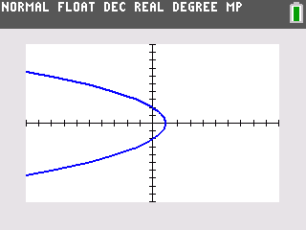  This activity utilizes MathPrintTM functionality and includes screen captures taken from the TI-84 Plus C Silver Edition. It is also appropriate for use with the TI-83 Plus, TI-84 Plus, and TI-84 Plus Silver Edition but slight variances may be found within the directions.  Compatible Devices:  - TI-84 Plus Family  - TI-84 Plus C Silver Edition  Associated Materials:  - ConicsInWinter_Student.pdf  - ConicsInWinter_Student.doc  Click HERE for Graphing Calculator Tutorials.

Conic Equations in Polar Notation
A conic is defined as the locus of points in a plane whose distance from a fixed point (focus) and a fixed line (directrix) is a constant ratio. This ratio is called the eccentricity, e, of the conic. The polar notation for the ellipse, hyperbola and parabola is given by the equation:
, or
where e is the eccentricity and d is the distance from the origin to the directrix.
Before beginning, students need to press  and change the settings to polar graphing mode (POLAR). |  | 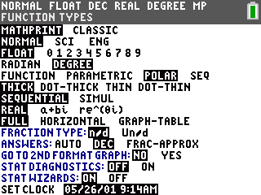
Then they are to press □ and enter the general polar equation for a conic section: . |  | 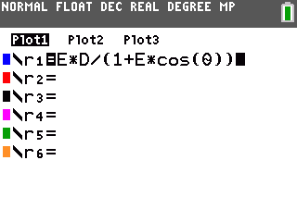
Before viewing the graph, they need to initialize the variables. Set D = 2 and E = 1. The arrow is entered by pressing . |  | 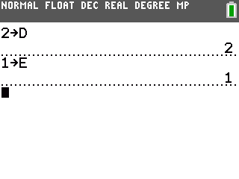
Which Conic is It?
Students should view the graph in a standard window. Allow them time to explore the effect of e (the eccentricity) on the shape of the graph. They should change the value of the variable from the home screen and then view the effect on the graph. Encourage them to explore positive, negative, fractional, and zero values for e.
- Parabola: e = 1 • Hyperbola: |e| > 1 • Ellipse: |e| < 1
The d Variable
Next, students will explore how the distance from the conic section to the directrix affects the graph. Have students set E = 1 and change the value of D.  To see how d affects different conic sections, students should also change the value of e to a value greater than 1 and then to a fractional value and then change the value of d again.  - The d variable controls the width of the conic sections. In addition to the width, the d variable also translates the hyperbola left and right. | 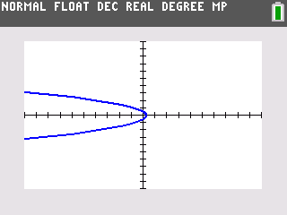
The Other Stuff
Students will observe how other changes with the equation will affect the graph. They need to press □ to edit the equation. They should observe what happens when the plus sign becomes a minus sign and what happens when cosine becomes sine.  - The plus/minus sign reflects the graph about the y-axis. Using cosine results in the graph having a horizontal orientation, while sine results in a vertical orientation. | 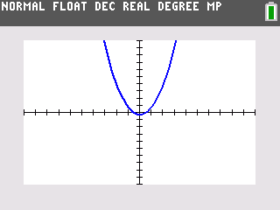
Extension – The a Variable
Students will explore what happens to the graph of a conic section when a phase shift is added to the cosine part of the equation. This situation can be represented this situation by the following equation:  - The a variable rotates the conic about the origin. It needs to be noted that this variable’s unit is radians, not degrees. This can also be thought of as rotating the polar axis. | 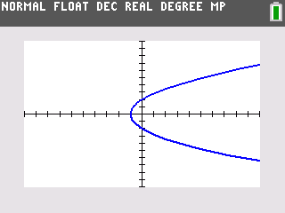
Solutions – Student Worksheet Exercises
1. Parabola
2. Hyperbola
3. Ellipse

