Problem 1 – The Fundamental Theorem of Algebra
Johann Carl Friedrich Gauss (1777–1855), German mathematician and physicist, first proved the Fundamental Theorem of Algebra.
This theorem states that every polynomial equation of degree greater than or equal to 1, with complex coefficients has at least one complex root.
Consider the polynomial f(x) = x³ + x².
- Factor this polynomial so that the degree of each factor is 1.

Set your graphing calculator to best display this polynomial by pressing  and matching the screen to the right.  Graph this polynomial by pressing □, entering the equation, and pressing . | 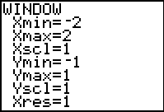
Calculate the zero where the graph crosses the x-axis by pressing   and selecting zero.  Now, use the arrow keys to move the cursor to  - the left of the zero and press e  - the right of the zero and press e  - the guess of the zero’s location and press e  Repeat this procedure for the other zero appearing on the graph. | 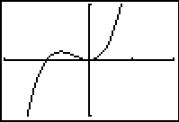
- Which zero matches which factor of the polynomial?

Since the factor x shows up twice, in the polynomial f(x) = x³ + x² = x·x·(x + 1), the polynomial has two distinct roots or zeros. The root x = 0 has multiplicity 2 and x = –1 has multiplicity 1.
- What do you notice about the multiplicities of the roots and the degree of the polynomial?

- Rewrite the roots as complex numbers.

Check For Understanding
1. How many complex roots does f(x) = x⁵ – 7x² + 3x + 2 have?

2. What is the multiplicity of the root x = 3 in f(x) = (x – 1)⁴(x – 3)²(x + 3)?

3. What is the total number of complex roots of f(x) = (x – 1)⁴(x – 3)²(x + 3)?

Problem 2 – Beyond Real
What about the polynomial f(x) = x² + 9?
Can you factor it? How do you find the zeros? What type of roots does it have?
Set your graphing calculator to best display this polynomial by pressing  and matching the screen to the right.  Graph this polynomial by pressing □, entering the equation, and pressing . |  | 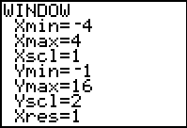
- How many complex roots does the polynomial have?

- What type(s) of roots does the polynomial have?

- How did the graph enable you to determine the root type?

Press M and press  on a + bi.  Return to the Home screen. Use the quadratic formula to determine the values of the roots. |  | 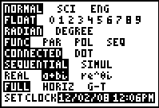

Problem 3 – The Mixed Case
Set your graphing calculator to best display the polynomial f(x) = x³ + x² + 4x + 4 by pressing  and matching the screen to the right.  Graph this polynomial by pressing □, entering the equation, and pressing . | 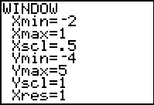
- How many complex roots or zeros does the polynomial have?
- How many of the roots or zeros are real?
- What are the real zeros?
- Rewrite it as a complex number as well as a factor.

- Divide the polynomial by this factor to aid you in the complete factorization of the polynomial. Make sure all the factors are linear when the factorization is complete.

- Identify all complex roots of the polynomial.

Extension – Even and Odd Multiplicity
What is meant by the term multiplicity?

The polynomial x(x – 3)² has been graphed to the right.  - What is the multiplicity of the factor x?  - What is the multiplicity of the factor (x – 3)?  - What do you notice about the graph at each zero? | 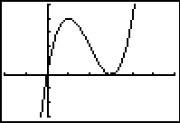
The polynomial (x – 3)³(x + 4)⁴ has been graphed to the right.  - What is the multiplicity of the factor x?  - What is the multiplicity of the factor (x – 3)?  - What do you notice about the graph at each zero? | 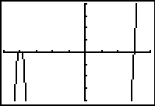
Investigate this further by using the Transformational graphing application by pressing  and selecting Transfrm.  Now press □ enter x^A. Press  and select ZStandard. | 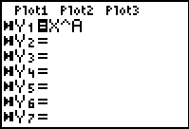
Notice the variable A is located on the left side of the screen. Enter different values for A and notice the effects they have on the graph.  - Describe how the graph at the x-value of the roots differs for roots with even multiplicities and for roots with odd multiplicities. | 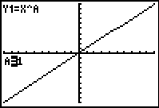

Application & Practice
The work for the first polynomial has been started. Find the two remaining factors, roots, and multiplicities for this polynomial. Complete the chart for the remaining polynomials.

Polynomial | Factor(s) | Roots | Multiplicity
f(x) = x⁴ – 9x³ + 27x² – 31x + 12 | x – 4 | 4 | 1
f(x) = x³ – 7x² + 11x – 5
f(x) = x⁵ + 9x⁴ + 31x³ + 63x² + 108x + 108

